UNITED STATES

SECURITIES AND EXCHANGE COMMISSION

WASHINGTON, D.C. 20549

SCHEDULE 14A

(Rule 14A-101)

SCHEDULE 14A INFORMATION

Proxy Statement Pursuant to Section 14(a) of

the Securities Exchange Act of 1934

Filed by the Registrant ☐

Filed by a Party other than the Registrant ☒

Check the appropriate boxes

- Preliminary Proxy Statement

- Confidential, for Use of the Commission Only (as permitted by Rule 14a-6(e)(2))

- Definitive Proxy Statement

- Definitive Additional Materials

- Soliciting material Pursuant to §240.14a-12

VICTORIA’S SECRET & CO.

(Name of Registrant as Specified In Its Charter)

BBRC International PTE Limited

BBFIT Investments PTE Limited

The BB Family International Trust

Brett Blundy

(Name of Person(s) Filing Proxy Statement, if other than the Registrant)

Payment of Filing Fee (Check the appropriate box):

- No fee required.

- Fee paid previously with preliminary materials.

- Fee computed on table below per Exchange Act Rules 14a-6(i)(4) and 0-11

On May 20, 2026, BBRC International PTE Limited, a Singapore private limited company (“BBRC”), together with the other participants named below (collectively the “Participants”), released the following letter to fellow Victoria’s Secret & Co. stockholders. BBRC or its fellow Participants may disseminate the letter or portions thereof from time to time.

May 20, 2026

Dear Fellow Victoria’s Secret Stockholders,

BBRC International Pte Limited (together with its affiliates, “BBRC” or “we”) beneficially owns 10,310,631 shares of Victoria’s Secret & Co. (“VS” or the “Company”), representing approximately 13.0% of the common stock outstanding and making BBRC the Company’s second-largest stockholder. We are writing to ask you to vote AGAINST Board Chair Donna A. James at the 2026 Annual Meeting of Stockholders scheduled for June 11, 2026.

The Board’s actions over the past two weeks have validated, rather than rebutted, the case for Board change we have been making since November 2025. On May 5, the Board publicly declared itself “unanimous in its support” of Ms. James and director Mariam Naficy – the two directors we had previously asked stockholders to hold accountable for the Company’s shortcomings. Six days later, on May 11, the Board disclosed that Ms. Naficy will not stand for reelection. On that same day, the Board announced a search for a new director with capabilities in “technology and artificial intelligence” – the exact skills gap we identified to the Board in our November 4, 2025 letter.

Six months passed between our diagnosis and the Board’s acknowledgment that we were correct. The substantive concerns we have raised – the poorly executed deployment of capital for share repurchases, the lack of accountability for the failed acquisition of Adore Me, the excessive tenure inherent in Ms. James’ 25 years of continuous service on this Board and its predecessor companies, and the Board’s continuing expertise gaps – remain unaddressed. Meanwhile, the Board has chosen to characterize our campaign as “distracting” and “self-interested” rather than engage with the substantive questions of governance and accountability we have raised.

We have over 45 years of global retail experience, including four decades dedicated to the lingerie and intimates sector. We have built and invested in two global lingerie businesses that were successfully sold to HanesBrands Inc. in 2018 for $400 million and to PLBY Group, Inc. in 2021 for $330 million. In addition, BBRC owns approximately 40% of Lovisa Holdings (ASX: LOV), a global jewelry retailer founded and chaired by BBRC founder Brett Blundy. Lovisa operates in more than 40 countries and has a market capitalization of approximately $1.6 billion.
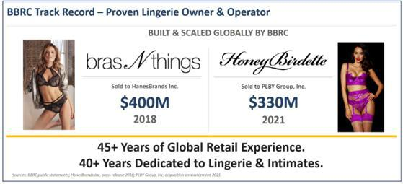

1

We invest to build durable value, not to react to short-term movements in a company’s stock price or pursue transient outcomes. Specifically:

- We are long-term investors – we began investing in VS four years ago and expect to remain engaged for years to come.

- We have a proven track record of creating value in the lingerie specialty category.

- We are not activist investors – we did not approach our investment in VS with the intention of seeking control or risking disruption with a broad governance campaign; this solicitation is designed to minimize possible disruption by focusing solely on accountability for just one problematic director.

Following our due diligence during the strategic review process that preceded VS’ separation from L Brands in 2021, we elected to invest with other stockholders in the Company’s common shares. Our investment expanded over time. Today, we have purchased almost 1,500 times the shares purchased by

the entire Board,¹ and our approximately 13.0% ownership position reflects both our long-term orientation and our conviction in the enduring strength of the Company’s brand.

SUPPORTING THE TURNAROUND AT VS REQUIRES VOTING

AGAINST THE CHAIR THAT NECESSITATED IT

Over the duration of our investment, VS has underperformed its self-selected peer group, the S&P 500 Consumer Discretionary Distribution & Retail Index, by approximately 92 percentage points – at its worst, the Company had returned 145 percentage points less than its benchmark.² The recent share price performance does not eliminate the need to hold the Board accountable for years-long weakness in governance and oversight.
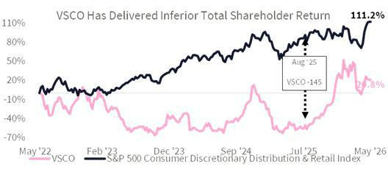

We believe a significant driver of this underperformance is the Board’s ineffective oversight of management, including the misallocation of approximately $1.2 billion to poorly executed buybacks and M&A with little demonstrable return.

- Form 3 and Form 4 filings by directors of the Company.

- FactSet. Total stockholder return measured from May 20, 2022 (the date of BBRC share purchases that required its Schedule 13G filing) through May 1, 2026. The S&P 500 Consumer Discretionary Distribution & Retail Index is the peer group used by the Company in its 2026 proxy statement to calculate its relative total stockholder return.

2

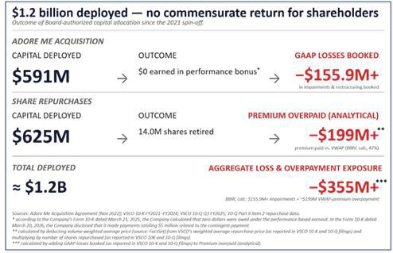

In our view, change is needed to the Board because the Chair of the Board has overseen VS for 25 years and excessive director tenure is inconsistent with effective corporate governance. That perspective is widely held: more than 75% of S&P 500 companies with director tenure limits cap service at 15 years
or less,³ and the CEO of the National Association of Corporate Directors has recommended a 10-year limit for public company directors.⁴ Unfortunately, we believe that the Board’s delayed transition away from the prior CEO and strategy it had endorsed confirms that the reduced independence commonly associated with excessive tenure has already materialized at VS, resulting in:

- Years of underperformance;

- Substantial erosion of stockholder value, and;

- The need for the current turnaround effort.

This solicitation is not about revisiting the past – it is about strengthening governance and Board oversight to protect the progress currently underway at VS. In our view, targeted Board refreshment is necessary to support the Company’s ongoing transformation. We have engaged with the Board extensively
on these issues, including the need for new leadership in the boardroom.⁵ Despite that effort, the Board has been unable to provide BBRC with a satisfactory explanation for its resistance to change and has chosen to retain Ms. James as Chair. In the face of the Board’s inaction, we have no choice but to bring this matter directly to our fellow stockholders. We are asking stockholders to hold Ms. James accountable for the documented failures of oversight and capital allocation that have occurred on her watch.

- The Conference Board. “Board Practices and Composition in the Russell 3000 and S&P 500: 2025 Edition” (November 17, 2025).
- Fortune. “How to embrace board turnover and do it the right way” (October 17, 2023).

- Donna James was a Director of Intimate Brands, Inc. as of March 23, 2001. Intimate Brands was a majority-owned subsidiary of The Limited, Inc. that was recombined with The Limited in 2002. The Limited, Inc. changed its name to Limited Brands, Inc. in May 2002 and to L Brands, Inc. in March 2013. VS separated from L Brands in August 2021. Ms. James was on the Board for the entire duration.

3

For the reasons detailed further below, we are soliciting stockholders to join us in voting AGAINST the election of Ms. James, whose overly long tenure as a director and continued service as Chair, in our view, underscore the Board’s failure to refresh its leadership.

UNDER MS. JAMES, STOCKHOLDERS HAVE SUFFERED YEARS OF VALUE DESTRUCTION, MISALLOCATED CAPITAL AND ANTI-STOCKHOLDER GOVERNANCE

Excessive Tenure Leads to Weakened Objectivity: Ms. James has overseen VS for 25 years, including 20 years working alongside Les Wexner on the boards of Intimate Brands, The Limited and L Brands, the Company’s former parent companies. As Chair of the Audit Committee at L Brands, Ms. James was named as a defendant in stockholder derivative litigation alleging:

ý

Breaches of fiduciary duty

ý A pattern of sexual harassment and

retaliation by Company executives

ý

Failures of Board oversight

ý

Ties to Jeffrey Epstein

The litigation resulted in a settlement requiring $90 million in governance reforms, including reforms directed at the very committee Ms. James chaired for 15 years.⁶ These reforms required, among other things, that express oversight of ethics and compliance, quarterly compliance reporting and annual reporting on the effectiveness of the compliance function were added to the L Brands’ Audit Committee charter.

In our view, Ms. James’ 25-year tenure is well beyond the range commonly associated with maintaining independent judgment and effective oversight in the boardroom. We believe that the negative effects of prolonged tenure on independence from management were readily visible in the Board’s hesitation to change management. After three years of declining performance, the Board belatedly replaced its CEO and CFO at the cost of approximately $13 million in severance and related expenses.⁷ The Board has taken credit for recent improvements in performance under CEO Hillary Super because she was appointed

while Ms. James was Chair.⁸ This attribution does not alter the fact that Ms. James presided over the years of underperformance that preceded Ms. Super’s appointment, including the succession process that necessitated the current turnaround.

- Rudi v. Wexner, et al., Case No. 2:20-cv-3068 (U.S. Dist. Ct. S.D. Ohio).
- The Company’s Form 10-K dated March 20, 2026.

- Victoria’s Secret & Co. Board Comments on BBRC Letter, November 4, 2025. 4

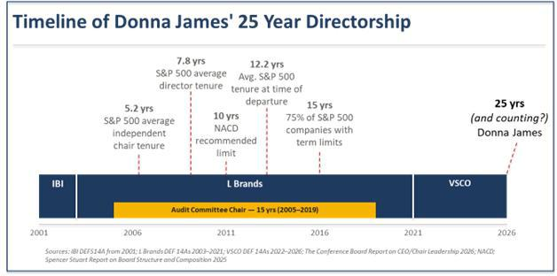

Ms. James presided as Chair over the failed strategic initiatives, outsized compensation packages and ineffective allocation of capital that led to sustained underperformance for stockholders. We believe accountability for the years of underperformance is necessary to preserve the current momentum. Nearly five years after the Company’s separation from L Brands, the need for leadership transition at the Board level is clear. The Chair role should now pass to another director.

Months of Turnaround Do Not Make Up for Years of Underperformance: The Board has overseen a significant deterioration in VS’ financial performance since it spun off from L Brands and became an independent public company in August 2021.
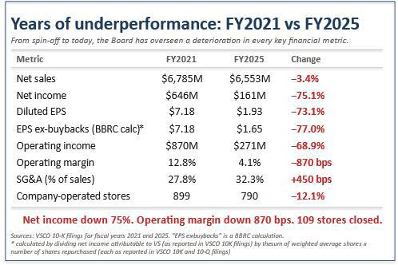

5

Missed Guidance: VS is on track to miss the 2026 financial targets it set at its October 2023 Investor Day by a wide margin. In 2023, the Company told stockholders that it aimed to generate mid-single-digit sales growth by 2026 so that it could deliver 2026 revenue of $7.4 billion. Operating margin was

projected to grow to low double digits by 2026, ending between 10% and 12%.⁹ The Company’s own fiscal 2026 revenue guidance of $6.85-$6.95 billion and approximately 6.5% operating margin falls well short of both targets. The executives who were on track to miss these targets have been replaced, but the individual responsible for Board leadership throughout this period – the Chair – remains in place. We believe that the Board’s leadership should be refreshed before the Company presents new targets or updated guidance.
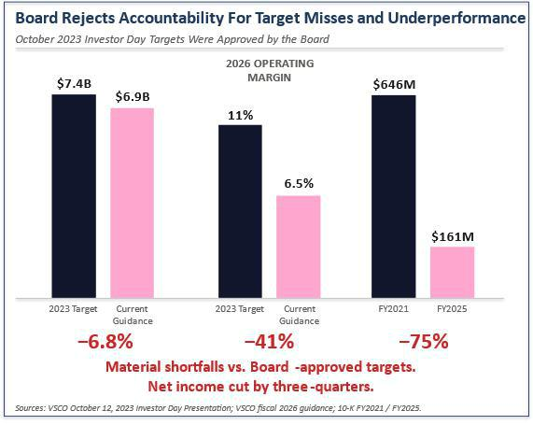

Failed Adore Me Acquisition: VS spent approximately $591 million¹⁰ to acquire Adore Me despite its lack of profitability and told stockholders when the deal closed in 2023 that it would be earnings and cash flow accretive that same year.¹¹ Instead, more than three years later, Adore Me has failed to meet its EBITDA and net revenue targets – with performance so underwhelming that the Company itself initially calculated that zero dollars were owed under the performance-based earnout.¹² The Company has also taken write-downs and restructuring charges against DailyLook while the search continues for its

strategic purpose, and management continues to explore ways “to optimize [Adore Me] within the broader portfolio.”¹³ As further evidence of the cost to stockholders of this failed acquisition, the Company announced more than $155.9 million of impairments and restructuring charges for Adore Me and
DailyLook in the latest fiscal quarter.¹⁴ We believe that Ms. James, as Chair of the Board, should be held accountable for this misallocation of capital and failed post-closing integration.

- The Company’s 2023 Investor Day presentation.

- The Company’s Form 10-K dated March 21, 2025 disclosed that the Company made an upfront cash payment of $391 million at closing and then made additional payments related to Adore Me totaling $200 million during 2024.
- The Company’s press release dated January 3, 2023.

- According to the Company’s Form 10-K dated March 21, 2025, the Company calculated that zero dollars were owed under the performance-based earnout. In the Form 10-K dated March 20, 2026, the Company disclosed that it made payments totaling $5 million related to the contingent payment.
- The Company’s FY 2025 results press release and earnings call dated March 5, 2026.

- The Company’s press release dated March 5, 2026.

6

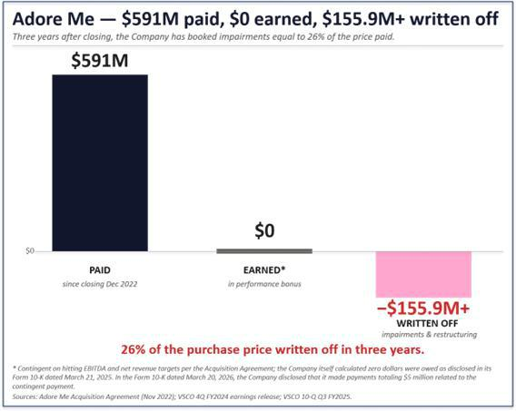

Ineffective Buyback Execution: The Board has authorized the identical amount of cash for repurchase programs with every renewal from 2021 to 2024 (totaling $1 billion authorized, of which $625 million has been spent), regardless of changes in profitability, cash flow and forecasts.¹⁵ In addition, the Board has failed to oversee the appropriate execution of these programs. VS’ volume-weighted average price from the L Brands separation through January 2026 was $30.34,¹⁶ but over the same time period, the Company repurchased shares as part of publicly announced programs at an average price of $44.53
per share.¹⁷ In total, 14.0 million shares were repurchased at an average price that was 47% above VWAP because, the Board failed to accelerate deployment of already-authorized capital as share prices fell. This is not a record of considered capital allocation – it is a record of indifference to stockholder value.

- Company Form 8-K filings on December 29, 2021, March 2, 2022, January 11, 2023, January 31, 2023 and March 6, 2024.

- FactSet.

- The Company’s Form 10-Q and 10-K filings, Part II Item 2 (Issuer Purchases of Equity Securities).

7

Unresponsiveness to Stockholders: Replacing the CEO in 2024 was the right decision. The question stockholders should ask is why it took this Board approximately three years and more than 70% destruction of stockholder value to reach that conclusion.
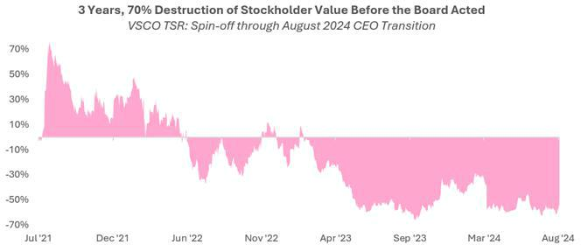

Equally concerning, given the Board’s repeated pattern of delayed corrective action, is the continuing disregard for declining stockholder support for the Company’s executive compensation structure.¹⁸
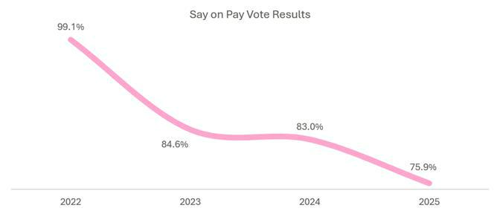

Despite the low support for executive compensation at the 2024 annual meeting, the Board did not take stockholder feedback into account and the Company’s 2025 proxy statement contained the same PSU design and the same severance provisions, plus a new discretionary modifier that further insulated management from accountability. The 2026 proxy statement exacerbates stockholder concerns, with the discretionary modifier’s metrics altered to, in BBRC’s view, less concrete factors such as “operational agility” that may already be incorporated into the executives’ regular compensation. The Board has set Fall season incentive targets below prior year actual results in three of the past four fiscal years, which progressively lowered the bar so that

declining performance would still trigger above-target payouts.¹⁹ The Company uses one benchmark to report total stockholder return to its stockholders (S&P 500 Consumer Discretionary Distribution & Retail Index) and a different benchmark to determine PSU executive payouts (S&P 1500 Specialty Retail Index) – the two benchmarks produce materially different three-year results, with no disclosed rationale for the difference.

- Approximately 25% of votes cast at the 2025 Annual Meeting opposed the compensation of the Company’s named executive officers.

- The Company’s proxy statements disclose that Fall season operating income targets were set below prior year actual results in fiscal year 2021, fiscal year 2022 and fiscal year 2023. Numerical analysis of the fiscal year 2024 proxy shows the Fall 2024 operating income target of $186 million was also set 9% below the Fall 2023 actual of $205 million. Over four years, the Fall operating income target declined from $475 million to $186 million – a 61% reduction – yet Fall 2024 paid out at 165.2% of target on actual operating income of $235 million, a figure that would have fallen below the minimum threshold as recently as fiscal year 2022.

8

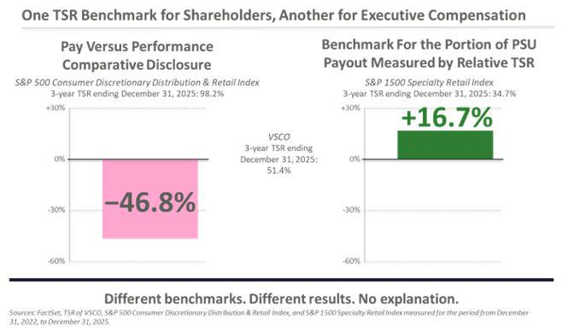

The Board’s unresponsiveness also extends to its own composition. Despite BBRC’s repeated calls for a stockholder representative on the Board, the Company’s most recent director addition was not independently sourced – the Company’s own proxy statement discloses that he was “initially identified as a potential director nominee by our CEO.”²⁰

Stockholders deserve a Board that learns from its mistakes – not one that takes credit for belatedly correcting them.

Change Is Needed Because the Board Refused to Take Sufficient Steps to Address These Concerns. Contrary to the Board’s assertion that it made multiple reasonable efforts to resolve BBRC’s concerns through settlement, the Board’s settlement proposal on January 9, 2026 was the third iteration of the same settlement structure the Board has offered since January 2024.

- The Company’s 2025 proxy statement (filed April 28, 2025), p.21.

9

- The Board’s initial proposal, in January 2024, was a limited information-sharing arrangement under which BBRC would have been confined to two management briefings over one year, with no new director, no capital allocation review and no governance changes. That proposal was conditioned on BBRC agreeing, among other standstill restrictions, not to nominate any candidates at VS’ 2024 annual meeting of stockholders.

- After BBRC continued to raise its concerns publicly through 2025, the Board tweaked its proposal in December 2025 to add one mutually agreed independent director, a capital allocation review and withdrawal of the poison pill. This revision remained subject to BBRC agreeing to a standstill which would restrict our ability to engage with stockholders and the Board.

- On January 9, 2026, the Board repeated the December 2025 framework without any material modification.

Across three iterations and 22 months, the Board has not addressed the core concerns of BBRC and, presumably, other stockholders. The “mutually agreed” director construct gives the Board a practical veto over the profile and independence of any new director, while leaving the Chair position and the Board composition that approved the Adore Me acquisition unchanged. The capital allocation review proposed by the Company remains undefined in scope, leadership, timeline or deliverable.

At no point during our engagement has the Board acknowledged the validity of the question of Chair succession or the inappropriateness of the Chair’s 25-year tenure. The Board has been willing to offer process – information sharing, a capital allocation review and even withdrawal of the rights plan – but has been silent on the central governance question BBRC has raised. Although the Board could have responded substantively and avoided this proxy contest, it has instead opted to saddle stockholders with the cost of advisory and legal fees, as well as the risk of management distraction.
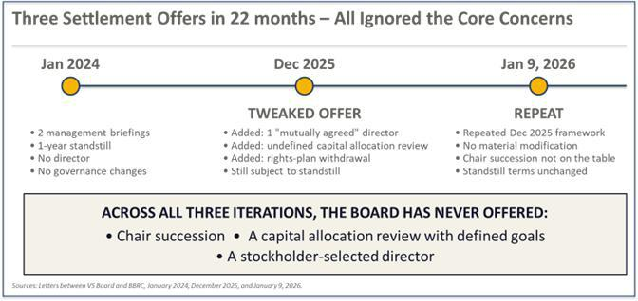

Poison Pill and Other Anti-Stockholder Governance: Following BBRC’s private expression of concerns about the Company’s strategy, governance and performance, the Board unilaterally adopted a restrictive poison pill without submitting it to stockholders for approval. According to the Company’s proxy statement, the Board has determined not to extend its poison pill. BBRC believes that the Board has tacitly acknowledged that its stockholder rights plan was out of step with governance best practices and stockholders’ best interests.

10

The Company’s non-executive directors collectively own 0.3% of the Company’s outstanding shares of Common Stock, approximately 97% of which was received through Company grants rather than personal investment. By contrast, BBRC has acquired almost 1,500 times the shares purchased by the entire Board. We believe the Board’s limited economic exposure has created a divergence with independent stockholders – a dynamic that may help explain the Board’s defensive posture toward BBRC, including its mischaracterization of our intentions as a significant stockholder.

Taken together with the Board’s tolerance of excessive tenure, defensive reaction to BBRC’s concerns and failure to meaningfully respond to declining shareholder support for executive compensation, we believe that stockholders must act to reset governance at VS.

THE UPCOMING ANNUAL MEETING IS AN OPPORTUNITY TO UPGRADE THE BOARD BY

VOTING AGAINST MS. JAMES

The Company’s director resignation policy, which requires any director who fails to receive majority support for their election to tender their resignation to the Board, empowers stockholders with a clear pathway to hold directors accountable. We strongly believe that voting AGAINST Ms. James’ reelection is an exercise in “addition by subtraction.” We believe a Board without Ms. James will bring improved oversight of capital allocation, focus on the core business rather than optimizing a failed acquisition and lead to the appointment of a new Chair who has the expertise this next phase of the turnaround demands.

If a director fails to receive a majority of the votes cast for their election as a result of our proxy solicitation, then we believe it would be inappropriate for any such director to continue to serve on the Board. In our view, a failure by the Board to accept any tendered resignations resulting from the votes of stockholders at the Annual Meeting would be a serious governance failure and directly contrary to a clear stockholder mandate. The progress now underway at VS does not diminish the need for accountability – it reinforces it. A Board committed to the Company’s next chapter must also reflect the lessons of the last one.

Ms. Super is building a new VS. She deserves a Board that matches her ambition and brings fresh judgment, governance discipline and stronger oversight to the boardroom. The Annual Meeting is an opportunity to support that future by voting AGAINST Ms. James, whose 25-year tenure as director and continued service as Chair exemplifies the Board’s failure to refresh its leadership. This change is not intended to disrupt the turnaround – it is intended to strengthen it.

Sincerely,
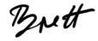

Brett Blundy

Founder

Please see additional materials at www.saratogaproxy.com/vsco

11

Cautionary Statement Regarding Forward-Looking Statements

This communication does not constitute an offer to sell or a solicitation of an offer to buy any of the securities described herein in any state to any person. The information herein contains “forward-looking statements”. Specific forward-looking statements can be identified by the fact that they do not relate strictly to historical or current facts and include, without limitation, words such as “may,” “will,” “expects,” “believes,” “anticipates,” “plans,” “estimates,” “projects,” “potential,” “targets,” “forecasts,” “seeks,” “could,” “should” or the negative of such terms or other variations on such terms or comparable terminology. Similarly, statements that describe our objectives, plans or goals are forward-looking. Forward-looking statements are subject to various risks and uncertainties and assumptions. There can be no assurance that any idea or assumption herein is, or will be proven, correct or that any of the objectives, plans or goals stated herein will ultimately be undertaken or achieved. If one or more of such risks or uncertainties materialize, or if the underlying assumptions of any of the BBRC Parties (as defined below) prove to be incorrect, the actual results may vary from outcomes indicated by these statements. Accordingly, forward-looking statements should not be regarded as a representation by any of the BBRC Parties that the future plans, estimates or expectations contemplated will ever be achieved.

Certain Information Concerning the Participants

The BBRC Parties have filed a definitive proxy statement and accompanying GOLD proxy card with the Securities and Exchange Commission (the “SEC”) to be used to solicit to vote AGAINST the election of a director nominee to the board of directors (“Board”) of Victoria’s Secret & Co. (“VSCO” or the “Company”) at the Company’s 2026 annual meeting of stockholders. Shortly after filing its definitive proxy statement with the SEC, BBRC expects to mail the Participants’ definitive proxy statement and accompanying GOLD proxy card to some or all of the stockholders entitled to vote at such meeting.

The participants in the proxy solicitation are BBRC, The BB Family International Trust (“BB Family Trust”), BBFIT Investments PTE Limited (“BBFIT”) and Brett Blundy (all o f the foregoing persons, together, the “BBRC Parties”).

As of the date hereof, the BBRC Parties in the aggregate directly own 10,310,631 shares of Common Stock of VSCO, par value $0.01 per share (the “Common Stock”) as further detailed below. As of the date hereof, (i) BBRC as the trustee of the BB Family Trust, may be deemed to beneficially own the 10,310,631 shares of Common Stock owned in the aggregate by BBFIT and the BB Family Trust, (ii) the BB Family Trust beneficially owns 100 shares of Common Stock held in record name and, as the sole shareholder of BBFIT, may be deemed to beneficially own the 10,310,531 shares of Common Stock owned by BBFIT, (iii) BBFIT beneficially owns 10,310,531 shares of Common Stock, and (iv) Mr. Blundy, as a director and sole shareholder of BBRC, may be deemed to beneficially own the 10,310,631 shares of Common Stock owned in the aggregate by BBFIT and the BB Family Trust.

IMPORTANT INFORMATION AND WHERE TO FIND IT

THE BBRC PARTIES STRONGLY ADVISE ALL STOCKHOLDERS OF VSCO TO READ BOTH THE BBRC PARTIES’ PROXY STATEMENT AND VSCO’S PROXY STATEMENT AND OTHER PROXY MATERIALS AS THEY BECOME AVAILABLE BECAUSE THEY WILL CONTAIN IMPORTANT INFORMATION. SUCH PROXY MATERIALS WILL BE AVAILABLE AT NO CHARGE ON THE SEC’S WEBSITE AT WWW.SEC.GOV. THE BBRC PARTIES’ DEFINITIVE PROXY STATEMENT AND OTHER RELEVANT DOCUMENTS, WHEN FILED, WILL ALSO BE AVAILABLE ON THE SEC WEBSITE, FREE OF CHARGE. IN ADDITION, THE PARTICIPANTS WILL PROVIDE COPIES OF THEIR PROXY STATEMENT WITHOUT CHARGE, WHEN AVAILABLE, UPON REQUEST. REQUESTS FOR COPIES SHOULD BE DIRECTED TO THE PARTICIPANTS’ PROXY SOLICITOR, SARATOGA PROXY CONSULTING LLC (STOCKHOLDERS CAN CALL TOLL-FREE: +1 (888) 368-0379).

12


YOUR VOTE IS IMPORTANT!

No matter how many shares of Common Stock you own, please give BBRC your proxy to vote “AGAINST” the election of Donna James, and in accordance with BBRC’s recommendations with respect to the other proposals expected to be presented at the Annual Meeting.

We urge you to SIGN, DATE, and MAIL the enclosed GOLD proxy card promptly in the envelope provided or VOTE BY INTERNET OR TELEPHONE using the unique control number and instructions on your GOLD proxy card.

If you have already voted for Donna James, a later-dated vote on the GOLD proxy card will override your prior vote.

If you have any questions, require assistance in voting your GOLD proxy card, or need additional copies of BBRC’s proxy materials, please contact Saratoga at the phone numbers listed below.

520 8th Avenue, 14th Floor
New York, NY 10018

(212) 257-1311

Stockholders call toll-free at (888) 368-0379

Email: info@saratogaproxy.com

