UNITED STATES
SECURITIES AND EXCHANGE COMMISSION
Washington, D.C. 20549

SCHEDULE 14A
Proxy Statement Pursuant to Section 14(a) of the
Securities Exchange Act of 1934
(Amendment No. )

Filed by the Registrant ☒
Filed by a party other than the Registrant ☐
Check the appropriate box:

☐ | Preliminary Proxy Statement

☐ | Confidential, for Use of the Commission Only (as Permitted by Rule 14a-6(e)(2))

☐ | Definitive Proxy Statement

☒ | Definitive Additional Materials

☐ | Soliciting Material under § 240.14a-12
Victoria’s Secret & Co.
(Name of Registrant as Specified in its Charter)
(Name of Person(s) Filing Proxy Statement, if other than the Registrant)
Payment of Filing Fee (Check all boxes that apply):

☒ | No fee required

☐ | Fee paid previously with preliminary materials

☐ | Fee computed on table in exhibit required by Item 25(b) per Exchange Act Rules 14a-6(i)(1) and 0-11

On May 27, 2026, Victoria’s Secret & Co. (the “Company”) issued the following letter to stockholders of the Company, a copy of which was mailed to stockholders in the format attached hereto as a courtesy PDF.

Dear Fellow Shareholders:
Victoria’s Secret & Co.’s (“VS&Co” or the “Company”) 2026 Annual Meeting of Shareholders (“Annual Meeting”) is scheduled for Thursday, June 11. The Board of Directors (the “Board”) needs your support to continue driving the Company’s outperformance. The Company’s strong operational and financial momentum under its Path to Potential strategy, as well as the decisive actions taken by the Board and management team, have positioned the Company for long-term success and value creation.
As part of our Path to Potential strategy, we are entering a new era of sexy. We are redefining what “sexy” means – it’s not one look or one definition but a feeling of confidence every woman owns for herself. That belief has guided every decision we have made in the past year, and we believe VS&Co is uniquely positioned to capture and reflect that feeling in a way no one else can.
We recently celebrated our new era of sexy by announcing our new stock ticker symbol “VSXY”. This change marks a meaningful milestone in the Company’s evolution and reflects the clarity VS&Co has today: in who it is, what it stands for, and how it shows up for customers.

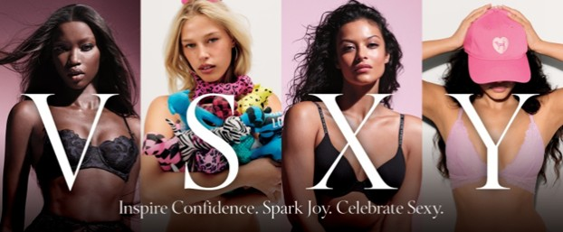
Our CEO, Hillary Super, said it best:
“VSXY is a marker of who we are today. A company standing fully in our identity and committed to inspiring confidence, sparking joy and celebrating sexy in all its forms. Sexy is deeply personal. If you asked a room full of women what it means, you’d get a different answer every time, and that diversity of expression is powerful.
VSXY is recognizable and aligns with our strategy and the progress we’ve made. It reflects our conviction and confidence in this work. We’re owning who we are, and we’re proud of it.”
Strong Reception to Our New Era of Sexy

 |  |  |  | 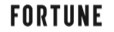  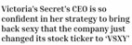
Our Transformation is Delivering Strong Results for Shareholders
The Path to Potential Strategy is delivering outperformance, quarter after quarter.

Since the Board announced Ms. Super’s appointment as CEO in August 2024, VS&Co has delivered a total shareholder return (“TSR”) of 193%, significantly outperforming the peer group used by research analysts, the S&P 500 Consumer Discretionary Distribution & Retail index and the S&P 600.1

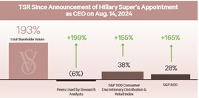
The Company’s Momentum is Being Overseen by a Highly Qualified Board of Directors
The Board’s actions have directly resulted in VS&Co’s successful turnaround. Continuing this momentum and creating long-term shareholder value remain the Board’s top priorities.
The Board’s skills are aligned with the Path to Potential strategy and include best-in-class capabilities across women’s intimates, apparel and beauty, strategic planning, brand transformation, marketing, consumer products, retail, digital commerce and financial experience.
The Board is overseen by Chair Donna James who brings a wealth of public company board leadership experience and a track record of creating value. Companies under Ms. James’s directorship outperformed the S&P 500 by 198% in total shareholder returns over the length of her tenure.2

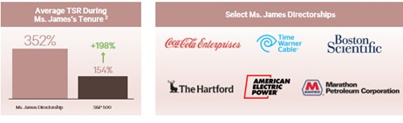
Your Board and management team remain focused on executing the Path to Potential strategy and driving shareholder value creation. We urge you to support continued execution of the Company’s strategy and use the WHITE proxy card to vote “FOR” all of VS&Co’s highly qualified nominees.
We appreciate your continued support.

1 | Source: FactSet as of May 26, 2026, measured against price at close on unaffected date of August 13, 2024, the date before the public announcement of Ms. Super’s appointment. Analyst peer group includes peers referenced by at least one analyst in initiating coverage research reports and is comprised of Abercrombie & Fitch, American Eagle, Gap, Urban Outfitters, Levi, Buckle, Carters, Torrid, Lululemon, Aritzia, Bath & Body Works, Capri, Dillard’s, Genesco, J.Jill, Kohl’s, Macy’s, The Children’s Place, Tilly’s, Tapestry, Zumiez, H&M, Industria de Diseno Textil (Inditex) and Vera Bradley. The S&P 500 Consumer Discretionary Distribution & Retail Index is a point of comparison referenced by BBRC in its public letter dated May 4, 2026; the index consists of S&P 500 companies classified under the distribution & retail sub-industry groups within the broader Consumer Discretionary sector of the GICS (Global Industry Classification Standard).
2 | Source: FactSet as of May 26, 2026, Company filings. Total shareholder returns’ average over length of tenure are compared against S&P 500 average and assume dividends are re-invested on ex-dividend date. Donna James’s directorship at Marathon Petroleum includes her position as independent director from July 2011 through October 2018 but not subsequently as board advisor. Other directorships included are Victoria’s Secret, Hartford Insurance, American Electric Power, Boston Scientific, Bath & Body Works, Time Warner, Coca-Cola Europacific Partners and CNO Financial Group.

Sincerely,
The Victoria’s Secret & Co. Board of Directors
For more information regarding VS&Co’s momentum and highly-qualified Board, please visit:
VSPathtoPotential.com
YOUR VOTE IS IMPORTANT.
To ensure your shares are represented at the Annual Meeting, please submit your vote TODAY: Use the WHITE Proxy Card to Vote “FOR” All of VS&Co’s Highly Qualified Nominees
If you have any questions or require any assistance with voting your shares, please call the Company’s proxy solicitor:

INNISFREE M&A INCORPORATED

Shareholders, please call: (877)
750-0831 (toll free from the U.S.
and Canada) or

+1 (412) 232-3651 (from all other
countries)

About Victoria’s Secret & Co
Victoria’s Secret & Co. (NYSE: VSCO) is a specialty retailer of modern, fashion-inspired collections including signature bras, panties, lingerie, sleepwear, apparel, sport and swim as well as award-winning prestige fragrances and body care. VS&Co is comprised of market leading brands, Victoria’s Secret and PINK, that strive to inspire confidence, spark joy and celebrate sexy. Additionally, Adore Me, our digital intimates brand serves women across budgets and lifestyles. We are committed to empowering our more than 30,000 associates across a global footprint of 1,420 retail stores in approximately 70 countries.
Safe Harbor Statement Under the Private Securities Litigation Reform Act of 1995
This document contains forward-looking statements within the meaning of the U.S. Private Securities Litigation Reform Act of 1995. These statements, which may be identified by words such as “estimate,” “commit,” “will,” “target,” “forecast,” “goal,” “project,” “plan,” “believe,” “seek,” “strive,” “expect,” “anticipate,” “intend,” “continue,” “potential” or the negative of these words and any similar expressions, involve risks and uncertainties, many of which are beyond our control, and are not guarantees of future performance. Actual results may differ materially from those expressed or implied in any forward-looking statement.
Factors that could cause actual results to differ include, among others: general economic conditions, inflation, and changes in consumer confidence and consumer spending patterns; market disruptions; uncertainty in the global trade environment, including tariffs and retaliatory measures; our ability to successfully implement our strategic plan; leadership changes and turnover in key positions; our ability to source, produce, distribute and sell merchandise globally, including risks related to geopolitical conflicts, supply chain disruptions (and related pricing impacts), currency fluctuations and labor disputes; fluctuations in freight, product input and energy costs; cybersecurity risks and our ability to maintain data security and privacy; shareholder activism matters; and other risks and uncertainties described in “Item 1A. Risk Factors” in our 2025 Annual Report on Form 10-K filed with the SEC on March 20, 2026.
All forward-looking statements are made only as of the date of this document. Except as may be required by law, we assume no obligation to make publicly available any update or other revisions to any of the forward-looking statements contained in this document.

