UNITED STATES

SECURITIES AND EXCHANGE COMMISSION

Washington, D.C. 20549

___________________

SCHEDULE 14A

(Rule 14a-101)

___________________

INFORMATION REQUIRED IN PROXY STATEMENT

SCHEDULE 14A INFORMATION

Proxy Statement Pursuant to Section 14(a) of the

Securities Exchange Act of 1934

Filed by the Registrant

☐

Filed by a Party other than the Registrant

☒

Check the appropriate box:

- Preliminary Proxy Statement

- Confidential, for Use of the Commission Only (as permitted by Rule 14a-6(e)(2))

- Definitive Proxy Statement

- Definitive Additional Materials

- Soliciting Material Under § 240.14a-12

VICTORIA’S SECRET & CO.

(Name of Registrant as Specified In Its Charter)

BBRC INTERNATIONAL PTE LIMITED

BBFIT INVESTMENTS PTE LTD

THE BB FAMILY INTERNATIONAL TRUST

BRETT BLUNDY

_______________________________________________________________

(Name of Persons(s) Filing Proxy Statement, if other than the Registrant)

Payment of Filing Fee (Check all boxes that apply):

- No fee required

- Fee paid previously with preliminary materials

- Fee computed on table in exhibit required by Item 25(b) per Exchange Act Rules 14a-6(i)(l) and 0-11

PRELIMINARY COPY SUBJECT TO COMPLETION

DATED MAY 19, 2026

BBRC INTERNATIONAL PTE LIMITED

May [•], 2026

Dear Fellow Victoria’s Secret Stockholder:

BBRC International PTE Limited, together with its affiliates (collectively, “BBRC”, “we” or “our”), is the beneficial owner of approximately 10,310,631 shares of common stock, representing approximately 13.0% of the outstanding shares of Victoria’s Secret & Co. (“Victoria’s Secret,” “VSCO” or the “Company”). We have been a long-term stockholder since 2022 and are currently the Company’s second-largest stockholder.

We are a global specialty retail platform founded and led by Brett Blundy, with a long track record of building, scaling and operating consumer brands across multiple markets. Across our portfolio, we have invested alongside management teams and worked closely with them over extended periods to develop and strengthen core businesses, with a focus on operational execution, disciplined capital allocation and long-term value creation. Our approach is grounded in partnership and alignment with management to drive sustainable performance.

We invested in Victoria’s Secret based on our belief in the strength of its brands and the Company’s significant unrealized potential. Over time, however, we have become increasingly concerned that this potential is not being realized due to persistent shortcomings in oversight, capital allocation and governance at the Board level. In our view, this is reflected in the Company’s underperformance relative to its peers since our investment and the absence of a credible path to closing that gap. After a sustained period of engagement with the Board that has not resulted in meaningful change or resolution, we have determined to bring our concerns directly to our fellow stockholders.

Since Victoria’s Secret became an independent public company following its spin-off from L Brands, Inc. in August 2021, the Company’s financial profile has weakened in ways that are difficult to reconcile with the passage of time and capital invested. Net sales declined from $6,785 million in fiscal year 2021 to $6,553 million in fiscal year 2025, while net income fell from $646 million to $161 million. Operating income decreased from $870 million to $271 million, with operating margins compressing from 12.8% to 4.1%. Over the same period, general, administrative and store operating expenses increased from $1,890 million, or 27.9% of net sales, to $2,113 million, or 32.3% of net sales, representing a $223 million increase in absolute dollars against lower revenue. The Company also reduced its store base from 899 locations as of January 29, 2022 to 790 locations as of January 31, 2026. Reported diluted earnings per share declined from $7.18 to $1.93, and while the Company repurchased $625 million of stock between fiscal years 2021 and 2023 at an average price of approximately $44.53 per share, reducing the diluted share count from 90 million to 83 million, that activity accounts for only a modest portion of the reported per-share performance; on the prior share base, fiscal year 2025 diluted earnings per share would have been approximately $1.79.

The Company’s capital allocation and strategic decisions during this period reflect the same trajectory. The acquisition of Adore Me, which was presented as a driver of digital growth and operational capability, resulted in $155.9 million of pre-tax charges in fiscal year 2025 alone, including a $119.6 million impairment of long-lived assets and $36.3 million in inventory reserves and severance associated with the restructuring of Adore Me and DailyLook fulfillment operations. These outcomes, together with the Company’s broader financial performance, developed under the oversight of the Company’s current Board of Directors (the “Board”). Victoria’s Secret’s CEO, Hillary Super, is now charged with executing the Company’s next phase, and that effort calls for Board-level judgment aligned with the demands of the business as it exists today. The leadership of the Board must reflect fresh perspective, governance discipline and capital allocation expertise, rather than one whose tenure spans the period of the Company’s relative decline.

At the Company’s 2026 Annual Meeting of Stockholders (the “Annual Meeting”), we are soliciting your support to vote AGAINST the election of Donna James, Chair of the Board (the “Opposed Company Nominee”). After careful consideration of our options to preserve our rights as a long-term stockholder and to protect our investment, we have elected not to nominate an alternative slate of directors at the Annual Meeting or seek to effect a change of control of the Company. Rather, we are asking stockholders to carefully consider our case for targeted change in the boardroom and to express a clear view on accountability at the Board level through the mechanism provided under the Company’s existing governance framework. We believe that Ms. James, who has served on the Board since 2021 and, prior to the

Company’s separation, served continuously on the boards of the Company’s predecessor entities, including L Brands, Inc., The Limited, Inc., and Intimate Brands, Inc. for a combined quarter century in total, bears responsibility for a series of decisions and oversight practices that, in our view, have contributed to the Company’s underperformance and strategic drift. The upcoming Annual Meeting presents an opportunity to align Board oversight with the demands of the business as it exists today and to support management’s execution of the Company’s strategy. This can be achieved by voting AGAINST the election of the Company’s overly tenured Chair, Ms. James, whose 25-year tenure has failed to deliver meaningful stockholder value. This change is not disruptive to the Company’s progress. It is intended to support and accelerate it.

After we filed our preliminary proxy statement, the Company filed a supplement to its proxy statement in response, disclosing, among other things, that Mariam Naficy, the other director we had opposed, would no longer be standing for re-election at the Annual Meeting. This development validates our case for change, but does not do enough to address stockholders’ concerns about weak management oversight and poor governance. For this reason, stockholders should vote against Ms. James at the Annual Meeting.

Importantly, under the Company’s governing documents, as described in the Company’s proxy statement, directors in uncontested elections are subject to a majority voting standard. Under this framework, each director nominee must receive a majority of votes cast with respect to his or her election. Votes cast “against” a nominee are included in the votes cast for purposes of this determination. In accordance with the Company’s director resignation policy, if any incumbent director does not receive the required level of support, such director’s resignation must be considered by the Board.

Accordingly, a vote AGAINST the election of the Opposed Company Nominee is not merely precatory or symbolic. It is a meaningful mechanism through which stockholders can prompt Board-level consideration, in accordance with the Company’s policies, of whether continued service by such directors is appropriate in light of not only the Company’s current priorities, but also the perspectives of its stockholders. We believe that the continued tenure of a 25-year director in the role of Chair raises significant questions regarding Board refreshment, independence of oversight and accountability to stockholders. In our view, the Annual Meeting represents an appropriate opportunity for stockholders to express their perspective on these issues.

We therefore urge you to carefully review the information contained in the attached Proxy Statement and to support our efforts by voting AGAINST the election of Ms. James using the enclosed GOLD proxy card.

The enclosed GOLD proxy card enables stockholders to vote on the election of directors and the other matters expected to be presented at the Annual Meeting. Because BBRC is not nominating an alternative slate of directors, the election of directors at the Annual Meeting is expected to be an uncontested election, and our solicitation is limited to seeking stockholder support to vote AGAINST the Opposed Company Nominee.

If you have previously voted using a proxy card furnished by the Company, you may revoke that proxy and change your vote by submitting a later-dated proxy using the enclosed GOLD proxy card or by voting virtually at the Annual Meeting. Only your most recent vote will be counted.

If you have any questions or require assistance in voting your shares, please contact Saratoga Proxy Consulting LLC, which is assisting us in this solicitation, at the contact information set forth below.

Thank you for your support,


Brett Blundy

BBRC International PTE Limited

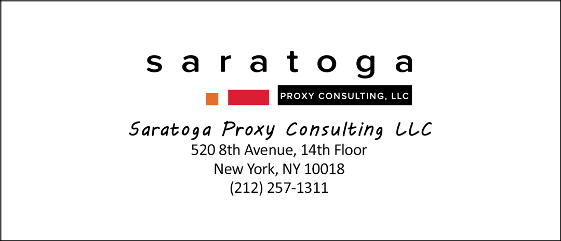
If you have any questions, require assistance in voting your GOLD proxy card, or need additional copies of BBRC’s proxy materials, please contact Saratoga at the phone numbers listed below.

Stockholders call toll-free at (888) 368-0379

Email: info@saratogaproxy.com

PRELIMINARY COPY SUBJECT TO COMPLETION

DATED MAY 19, 2026

2026 ANNUAL MEETING OF STOCKHOLDERS

OF

VICTORIA’S SECRET & CO.

PROXY STATEMENT

OF

BBRC INTERNATIONAL PTE LIMITED

PLEASE SIGN, DATE AND MAIL THE ENCLOSED GOLD PROXY CARD TODAY

BBRC International PTE Limited, together with its affiliates (collectively, “BBRC”, “we” or “our”), is the beneficial owner of approximately 10,310,631 shares of common stock, par value $0.01 per share (the “Common Stock”), of Victoria’s Secret & Co., a Delaware corporation (“Victoria’s Secret”, “VSCO” or the “Company”), representing approximately 13.0% of the outstanding shares of Common Stock. We are soliciting your proxy in connection with the Company’s 2026 Annual Meeting of Stockholders (including any adjournments or postponements thereof and any meeting which may be called in lieu thereof, the “Annual Meeting”) scheduled to be held virtually on June 11, 2026, at 8:30 a.m., Eastern Time, at www.proxydocs.com/VSCO, to vote AGAINST the election of Donna James (the “Opposed Company Nominee”) to the Company’s Board of Directors (the “Board”). This Proxy Statement and the enclosed GOLD proxy card are first being furnished to stockholders on or about May [•], 2026.

Our GOLD proxy card will allow stockholders to vote on the following proposals that are being presented by the Company for stockholder consideration at the Annual Meeting:

The Company’s proposal to elect nine directors to serve until the 2027 annual meeting of stockholders;

The Company’s proposal to approve, on an advisory basis, the compensation of the Company’s named executive officers;

The Company’s proposal to ratify the appointment of Ernst & Young LLP as the Company’s independent registered public accounting firm for fiscal year 2026; and

To transact such other business as may properly come before the Annual Meeting or any adjournments or postponements thereof.

Our enclosed GOLD proxy card provides stockholders with the ability to vote on each of the foregoing matters.

As of the date hereof, the BBRC Participants (as defined below) beneficially own 10,310,631 shares of Common Stock (the “BBRC Shares”). We intend to vote the BBRC Shares “AGAINST” the election of the Opposed Company Nominee and, except as otherwise set forth in this Proxy Statement, “FOR” the election of the remaining Company director nominees standing for election at the Annual Meeting (collectively, the “Unopposed Company Nominee” and, together with the Opposed Company Nominee, the “Company Nominees”).

By voting “AGAINST” the election of Donna James, Chair of the Board, stockholders can express their view that greater accountability is required at the Board level. We therefore urge stockholders to vote “AGAINST” the election of Ms. James at the Annual Meeting.

The Company Nominees are not nominees of BBRC and are not participants in this solicitation. BBRC is not nominating an alternative slate of directors at the Annual Meeting. Accordingly, this solicitation is limited to seeking stockholder support to vote “AGAINST” the Opposed Company Nominee.

The enclosed Proxy Statement and GOLD proxy card includes the ability to vote for all the Company Nominees, including the Unopposed Company Nominees. We can provide no assurance that any of the Company Nominees will serve as directors if elected.

1

The Company has set the close of business on April 15, 2026 as the record date for determining shareholders entitled to notice of and to vote at the Annual Meeting (the “Record Date”). The mailing address of the principal executive offices of the Company is Four Limited Parkway, Reynoldsburg, Ohio 43068. Stockholders of record at the close of business on the Record Date will be entitled to vote at the Annual Meeting. According to the Company, as of the Record Date, there were 79,425,668 shares of Common Stock outstanding and entitled to vote at the Annual Meeting.

We urge you to carefully consider the information contained in this Proxy Statement and then support our efforts by signing, dating and returning the enclosed GOLD proxy card or by voting via Internet in accordance with the instructions on the enclosed GOLD proxy card.

IF YOU MARK FEWER THAN A TOTAL OF NINE (9) “FOR,” “AGAINST” OR “ABSTAIN” BOXES WITH RESPECT TO THE ELECTION OF DIRECTORS, YOUR SHARES WILL ONLY BE VOTED WITH RESPECT TO THE NOMINEES YOU HAVE SO MARKED, IN THE MANNER YOU HAVE DIRECTED.

THIS SOLICITATION IS BEING MADE BY BBRC AND NOT ON BEHALF OF THE BOARD OR MANAGEMENT OF THE COMPANY. BBRC IS NOT AWARE OF ANY OTHER MATTERS TO BE BROUGHT BEFORE THE ANNUAL MEETING OTHER THAN THOSE DESCRIBED IN THIS PROXY STATEMENT. SHOULD OTHER MATTERS, WHICH BBRC IS NOT AWARE OF A REASONABLE TIME BEFORE THIS SOLICITATION, BE PROPERLY BROUGHT BEFORE THE ANNUAL MEETING, THE PERSONS NAMED AS PROXIES IN THE ENCLOSED GOLD PROXY CARD WILL VOTE ON SUCH MATTERS IN THEIR DISCRETION.

BBRC URGES YOU TO VOTE VIA THE INTERNET OR BY SIGNING, DATING AND RETURNING THE ENCLOSED GOLD PROXY CARD TO VOTE “AGAINST” THE ELECTION OF DONNA JAMES TO THE BOARD AT THE ANNUAL MEETING.

IF YOU HAVE ALREADY SENT A PROXY CARD FURNISHED BY COMPANY MANAGEMENT OR THE BOARD, YOU MAY REVOKE THAT PROXY AND VOTE ON EACH OF THE PROPOSALS DESCRIBED IN THIS PROXY STATEMENT BY SIGNING, DATING AND RETURNING THE ENCLOSED GOLD PROXY CARD. THE LATEST DATED PROXY IS THE ONLY ONE THAT COUNTS. ANY PROXY MAY BE REVOKED AT ANY TIME PRIOR TO THE ANNUAL MEETING BY DELIVERING A WRITTEN NOTICE OF REVOCATION OR A LATER DATED PROXY FOR THE ANNUAL MEETING OR BY VOTING VIRTUALLY AT THE ANNUAL MEETING.

Important Notice Regarding the Availability of Proxy Materials for the Annual Meeting — This Proxy Statement and our GOLD proxy card are available at

www.saratogaproxy.com/vsco

2

IMPORTANT

Your vote is important, no matter how many shares of Common Stock you own. BBRC urges you to sign, date and return the enclosed GOLD proxy card today to vote AGAINST the election of Donna James to the Board and in accordance with BBRC’s recommendations with respect to the other proposals expected to be presented at the Annual Meeting.

- If your shares of Common Stock are registered in your own name, you may vote (i) through the Internet at any time prior to 11:59 p.m., Eastern Time, on June 10, 2026 by following the instructions on the enclosed GOLD proxy card, or (ii) by signing and dating the enclosed GOLD proxy card and returning it to BBRC, c/o Saratoga Proxy Consulting LLC (“Saratoga”), in the enclosed postage-paid envelope.

- If your shares of Common Stock are held in a brokerage account, bank or other nominee, you are considered the beneficial owner of the shares of Common Stock. These proxy materials, together with a GOLD voting instruction form, are being forwarded to you by your broker, bank or other nominee. As a beneficial owner, you must instruct your broker, bank or other nominee how to vote your shares. Your broker, bank or other nominee cannot vote your shares on your behalf without your instructions.

- Depending upon your broker, bank or other nominee, you may be able to vote your shares by telephone or by the Internet. Please refer to the enclosed GOLD voting instruction form for instructions on how to vote electronically. You may also vote by signing, dating and returning the enclosed GOLD voting instruction form.

- You may vote your shares virtually at the Annual Meeting. Even if you plan to attend the Annual Meeting, we recommend that you submit your GOLD proxy card or voting instruction form by Internet or by mail prior to the applicable deadline so that your shares will be represented at the Annual Meeting if you later decide not to attend.

Because only your latest dated proxy will be counted, we urge you not to return any proxy card you receive from the Company. If you have already submitted a proxy card furnished by the Company, you may revoke that proxy by submitting a later-dated proxy using the enclosed GOLD proxy card or by voting virtually at the Annual Meeting.
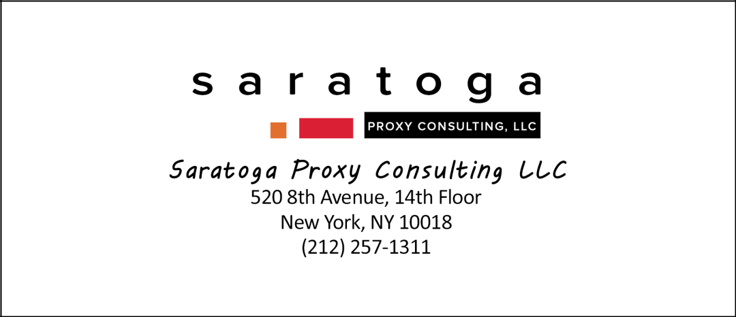

If you have any questions, require assistance in voting your GOLD proxy card, or need additional copies of BBRC’S proxy materials, please contact Saratoga at the phone numbers listed below.

Stockholders call toll-free at (888) 368-0379

Email: info@saratogaproxy.com

3

BACKGROUND FOR THE SOLICITATION

The summary below details the significant communications and interactions between BBRC and Victoria’s Secret in the lead up to this solicitation. This summary does not purport to describe every conversation or interaction among members of the Board, the Company’s management, the Company’s advisors and representatives of BBRC and their respective advisors relating to the matters described herein.

- BBRC brings over 45 years of global retail experience, including four decades dedicated to the lingerie and intimates sector. Among its investments in the space, BBRC has built two global lingerie businesses that were successfully sold to HanesBrands Inc. in 2018 for AUD $500 million and to PLBY Group, Inc. in 2021 for $330 million USD.

- In April 2021, in connection with the evaluation of strategic alternatives while the Company was still part of L Brands, Inc. (“L Brands”), its former parent company and Board ran a structured process through its financial advisor to solicit potential buyers for the business. As part of that process, BBRC submitted a private proposal to acquire VSCO, reflecting our early conviction in the business and willingness to deploy significant capital at a pivotal moment prior to the Company’s eventual spin-off in August 2021.

- BBRC chose not to participate in the spin-off or purchasing of VSCO shares upon listing as the valuation did not align with BBRC’s belief at the time.

- On July 30, 2021, L Brands, Inc. agreed to resolve allegations that L Brands’ officers and directors breached their fiduciary duties, including failures of board oversight, an alleged pattern of sexual harassment and retaliation by company executives, and alleged ties to Jeffrey Epstein. The settlement required investing $90 million in governance reforms. Ms. James was named as a defendant in that case due, in part, to her role as Chair of the L Brands Audit Committee from 2005 to 2020.

- Since April 2022, BBRC has been regularly engaged at a high level with the Company through direct communications with management and members of the Board regarding capital allocation, governance, Board composition and strategic direction, including sharing its views on operating performance and oversight.

- On April 12, 2022, a representative of BBRC contacted Martin Waters, then-CEO of the Company, to formally introduce Brett Blundy, highlight Mr. Blundy’s demonstrated track record as a retail entrepreneur over the past forty years and convey that Mr. Blundy is not an activist investor and likes to support strong management teams.

- On May 4, 2022, Mr. Blundy wrote to Company management, including Mr. Waters and then-CFO Timothy Johnson, stating that BBRC had been increasing its investment in the Company and expressing the view that, based on his experience in the retail industry, the Company should prioritize reducing its debt to approximately $500–$600 million before pursuing share repurchases.

- On May 6, 2022, the Company responded, noting that it was in a quiet period and not actively engaging with investors, and indicating that it would address capital structure and allocation strategy following its first quarter earnings call. The Company further stated that it believed its existing debt levels were appropriate relative to peers and that share repurchases were supported by the majority of stockholders at prevailing valuations.

- On May 10, 2022, following visits to Company retail locations, Mr. Blundy wrote to Mr. Waters to note positive observations regarding the Company’s “Stores of the Future” concept, reiterate that BBRC continued to increase its investment and request a meeting with the Company’s product team.

- On May 31, 2022, BBRC filed a Schedule 13G reporting beneficial ownership of 6,922,374 shares of Common Stock, representing approximately 8.3% of the Company’s then-outstanding shares.

- On June 8, 2022, Mr. Blundy wrote to Mr. Waters to request a call and assistance in connecting with members of the Board, highlight his experience in the lingerie sector and reiterate that BBRC continued to increase its investment in the Company.

- On September 6, 2022, a representative of BBRC emailed Mr. Johnson and Kevin Wynk, the Company’s VP for External Financial Reporting and Investor Relations, to arrange in-person meetings between BBRC and members of the Board.

4

- On October 6, 2022, in advance of a meeting with the Company in Chicago, Mr. Blundy emailed Ms. James and shared BBRC’s “Principles of Ownership,” outlining the firm’s long-term, owner-oriented approach to investing, governance and capital allocation, including its emphasis on return on equity, disciplined use of capital, lean and effective boards and management teams operating with an ownership mindset.

- On October 13, 2022, BBRC met with Ms. James and Anne Sheehan, Chair of the Board’s Nominating and Governance Committee, prior to the Company’s investor day presentation and discussed the Company’s financial performance and outlook.

- In early January 2023, the Company contacted Mr. Blundy regarding certain option transactions reported on BBRC’s Form 4, indicating that such transactions may have inadvertently resulted in short-swing profits under Section 16 of the Exchange Act. Representatives of the Company and BBRC discussed the matter with counsel and, to resolve the matter expeditiously, on January 10, 2023, BBRC filed an amended Form 4 with the SEC and remitted to the Company approximately $51,000, representing potential inadvertent short-swing profits from the transactions.

- On March 24, 2023, the Company contacted representatives of BBRC to provide availability for a meeting between Mr. Blundy and Company leadership, including Messrs. Waters and Johnson and Ms. James.

- On April 28, 2023, the Company provided Mr. Blundy with materials relating to its “State of the Fleet” presentation.

- On May 11, 2023, Mr. Blundy wrote to Ms. James reiterating BBRC’s conviction in its investment in the Company and formalizing its views ahead of the Company’s 2023 annual meeting of stockholders, including its voting intentions with respect to certain directors. In that correspondence, Mr. Blundy set forth BBRC’s perspective on Board composition, emphasizing the importance of experienced, independent decision-makers with senior operating backgrounds and advocating for a smaller, more focused Board.

- On May 12, 2023, Ms. James replied to Mr. Blundy, acknowledging BBRC’s perspectives and engagement with the Company and responding to BBRC’s views regarding Board composition and director qualifications.

- During the week of July 24, 2023, Mr. Blundy visited VSCO store locations in New York City and met with Messrs. Waters and Johnson in connection with the Company’s Atlantic Terminal store launch.

- On August 30, 2023, Mr. Blundy wrote to Ms. James reiterating concerns regarding the Company’s decision to expand the Board, reminding her of his long-standing view that larger boards do not serve stockholders effectively and result in added costs to the Company.

- On September 1, 2023, Ms. James replied to Mr. Blundy’s August 30, 2023 note, responding to Mr. Blundy’s views.

- On October 11, 2023, Mmes. James and Sheehan met with Mr. Blundy and a representative of BBRC to discuss the Company’s performance and ongoing engagement with BBRC as a significant stockholder ahead of the Company’s investor day. During that meeting, the parties discussed, at a high level, the potential for Mr. Blundy to join the Board.

- On October 27, 2023, following the Company’s investor day held on October 12, 2023, Mr. Blundy sent an email to Mmes. James and Sheehan expressing his interest in being appointed to the Board. In that correspondence, Mr. Blundy highlighted his extensive experience in global retail and lingerie businesses, his prior public company board service and his significant ownership position in the Company, and indicated his preference to obtain the Board’s support for his appointment, while noting that he would be prepared to seek election through stockholders if necessary. On that same day, Ms. James emailed Mr. Blundy a copy of the Company’s form questionnaire for directors & officers and confirmed that the Nominating and Governance Committee had agreed to evaluate him as a director candidate “using the same criteria and process that it uses to evaluate all candidates.”

5

- On December 15, 2023, Ms. Sheehan requested a follow-up meeting with Mr. Blundy. In that communication, Ms. Sheehan indicated that the Committee had additional questions relating to Mr. Blundy’s potential candidacy as a director, including with respect to allegations relating to certain BBRC portfolio companies, Mr. Blundy’s perspectives on M&A and the concerns he had raised regarding the Company’s performance.

- On December 18, 2023, Mr. Blundy responded to Ms. Sheehan, reiterated his desire to join the Board with its support and expressed concern regarding the pace of the Company’s proposed process in light of the upcoming advance nomination window for the 2024 annual meeting of stockholders. Mr. Blundy confirmed that he only supports cultures that create trust, integrity and treating all with respect at his portfolio companies. He also shared his views on M&A growth and his concerns about the deteriorating performance of the business.

- During the week of January 8, 2024, Mr. Blundy and members of the Board held discussions regarding his potential appointment to the Board. Members of the Board raised purported concerns that a 2021 derivative settlement agreement entered into in connection with L Brands, which imposed a series of governance and oversight measures on L Brands that were carried forward to VSCO following the spin-off, could limit their ability to appoint Mr. Blundy as a director. In that context, the Board also indicated that it was considering an alternative framework for engagement, including an information-sharing arrangement in lieu of Board representation.

- On January 19, 2024, the Company proposed an information-sharing arrangement that would limit BBRC to two management briefings per year. The proposed arrangement provided no Board representation, no capital allocation review, and no governance changes to address the concerns BBRC had raised over Board tenure and oversight. In exchange, BBRC would have had to agree to confidentiality and use restrictions, as well as a standstill that, among other things, would have limited BBRC’s ability to seek Board representation — including by prohibiting BBRC from nominating directors or otherwise pursuing Board representation at the Company’s 2024 annual meeting of stockholders.

- On January 23, 2024, Mr. Blundy declined the Company’s proposed framework, noting that, while he appreciated the Board’s engagement and the effort reflected in the proposal, the structure did not provide sufficient proactive, upfront opportunity for him to share insights, offer perspective and participate in a meaningful way. Mr. Blundy observed that the proposed arrangement appeared to contemplate engagement only after substantive Board discussions had already occurred, rather than during the decision-making process itself, and therefore did not align with his objective of contributing constructively alongside the Board. He further indicated his continued preference to work with the Board toward a mutually agreeable outcome.

- On February 1, 2024, when VSCO had delivered total shareholder return of negative 37.3% since the separation from L Brands, BBRC reported beneficial ownership of 7,603,019 shares of Common Stock, representing approximately 9.8% of the Company’s then-outstanding shares, on Schedule 13D, and indicated its intent to engage with management and the Board regarding opportunities to enhance stockholder value, including potential improvements to Board composition.

- On February 13 and 14, 2024, the Company, through its counsel, Kirkland & Ellis LLP (“Kirkland & Ellis”), engaged in discussions with counsel for BBRC regarding the Company’s proposed information sharing arrangement and the Board’s position on appointing Mr. Blundy to the Board. Kirkland & Ellis reiterated the Company’s position that the 2021 L Brands derivative settlement agreement created, in the Company’s view, constraints that limited the Board’s ability to appoint Mr. Blundy as a director. BBRC did not share the Company’s interpretation of the L Brands settlement agreement, as the agreement contains no express restriction on the appointment of any particular individual as a director. BBRC believes that the Board’s reliance on the 2021 L Brands derivative settlement agreement to block a major stockholder from joining the Board is particularly objectionable because the settlement — and the accompanying $90 million of investment in governance changes — arose from deficiencies that occurred during Ms. James’ tenure as Chair of L Brands’ Audit Committee from 2005 to 2020. BBRC believes that this incident raises serious questions about the absence of good faith effort in the Board’s engagement with a shareholder.

In the course of those discussions, Kirkland & Ellis also advised BBRC’s counsel that the Board was not open to Mr. Blundy’s appointment and the Company would respond in an adversarial manner if BBRC pursued a formal nomination process. In an effort to preserve the opportunity for constructive engagement, BBRC elected not to nominate directors at the Company’s 2024 annual meeting of stockholders and instead continued to engage privately with the Company.

6

- On March 7, 2024, a representative from BBRC e-mailed the Company to share BBRC’s perspective on capital return preferences.

- On June 13, 2024, at the Company’s 2024 annual meeting of stockholders, a representative of BBRC asked a question regarding the Adore Me acquisition. The Company did not address the question and, instead, offered a follow-up call.

- On September 5, 2024, Mr. Blundy and Ms. James met to discuss the Company’s performance, capital allocation priorities and strategic direction, including the Company’s acquisition of Adore Me and broader portfolio focus.

- On September 12, 2024, Mr. Blundy sent an email to Ms. James reiterating his concerns regarding the Company’s acquisition of Adore Me, describing the acquisition as “a strategic misstep” for the Company and “a poor use of shareholder capital.” In that correspondence, Mr. Blundy advocated for a renewed focus on the Victoria’s Secret brand, rather than pursuing a “house of brands” strategy, and suggested that the Company consider exiting or restructuring non-core assets, while also indicating his willingness to engage with the Board on capital allocation matters, including dividends and share repurchases.

- On December 4, 2024, the Company raised concerns with Mr. Blundy regarding a BBRC representative’s visits to VSCO retail locations during the course of a broader site visit trip conducted by BBRC across multiple companies as part of its ongoing diligence of existing and potential retail investments. Mr. Blundy promptly responded on December 5, 2024, reiterating BBRC’s commitment to compliance with applicable confidentiality obligations and securities laws.

- Over the following weeks, counsel for the Company and counsel for BBRC exchanged correspondence regarding the matter. BBRC disputed the Company’s characterization of the underlying conduct but, in the interest of resolving the matter promptly, agreed to destroy any materials referenced in the Company’s correspondence.

- On January 20, 2025, Ms. James emailed a representative of BBRC following his outreach, acknowledging BBRC’s position as a significant investor, noting her prior engagement with Mr. Blundy and expressing a willingness to meet with Mr. Blundy. In that same correspondence, Ms. James referenced BBRC’s visits to VSCO retail locations.

- On February 7, 2025, Kirkland & Ellis wrote to counsel for BBRC and agreed that the Company would not pursue the matter further if BBRC and its representatives destroyed all materials raised in the December 23, 2024 and January 20, 2025 letters to BBRC.

- On February 11, 2025, counsel for BBRC delivered a letter to Kirkland & Ellis confirming that, while BBRC disputed the Company’s characterization of the underlying conduct, in the interest of resolving the matter promptly, BBRC had destroyed all materials referenced in the December 23, 2024 and January 20, 2025 correspondences and that the matter was resolved.

- On February 14, 2025, a representative of BBRC met in person with Mmes. James and Sheehan to discuss BBRC’s investment and ongoing engagement with the Company. The discussion centered on enhancing the parties’ working relationship and identifying areas where Mr. Blundy’s industry experience could be most valuable to the Company.

- On March 12, 2025, at a time when the Company’s stock price had returned negative 59.6% since the separation from L Brands and represented an attractive investment opportunity, BBRC increased its investment and filed an amendment to its Schedule 13D reporting beneficial ownership of 9,175,019 shares of Common Stock, representing approximately 11.7% of the Company’s then-outstanding shares.

- On April 1, 2025, when VSCO had delivered total shareholder return of negative 56.8% since the separation from L Brands, BBRC filed an amendment to its Schedule 13D reporting beneficial ownership of 10,098,131 shares of Common Stock, representing approximately 12.8% of the Company’s then-outstanding shares.

7

- In connection with its increased investment, BBRC identified that prior acquisitions of the Company’s shares required filings under the Hart-Scott-Rodino Antitrust Improvements Act (the “HSR Act”). Upon identifying this obligation, BBRC promptly engaged antitrust counsel and, on April 8, 2025, proactively notified the Company that it had recently crossed the applicable ownership threshold and was completing the required filings. BBRC’s corrective HSR filings were submitted on April 18, 2025, and the applicable waiting periods expired on May 21, 2025. BBRC takes its regulatory compliance obligations seriously. Under the HSR Act, the primary obligation to identify and make pre-merger notification filings rests with the acquiring person. BBRC self-identified the issue, promptly retained antitrust counsel, and voluntarily submitted corrective filings, consistent with the approach the FTC has historically applied to first-time, inadvertent filers who come forward voluntarily. To ensure future compliance with HSR reporting requirements, BBRC also instituted several measures and controls, including developing and implementing an annual HSR training program by antitrust counsel. Yet in its May 20, 2025 press release announcing the adoption of the Rights Plan, the Company cited BBRC’s HSR filing history as one of the factors supporting the Board’s decision to adopt a shareholder rights plan.

- On April 30, 2025, a representative of BBRC emailed Ms. James to follow up on prior discussions and raise questions regarding the Company’s approach to Board composition, including Board size, referencing BBRC’s investment principles favoring smaller boards.

- Throughout May 2025, including on May 2, May 6, May 8 and May 12, representatives of BBRC and the Company engaged in a series of email exchanges regarding the Company’s decision to expand the size of the Board and nominate an additional director. During these exchanges, BBRC consistently expressed its opposition to increasing the size of the Board, reiterating its view that larger boards are less effective, increase costs and do not serve stockholders’ interests. BBRC also questioned the rationale for adding a new director without removing an incumbent director and sought to understand why the Company had not engaged with Mr. Blundy, as a significant stockholder, in connection with the Board expansion or considered him for the additional seat given his experience and ownership position. In responses on May 2 and May 12, the Company maintained that its Board size was consistent with market practice and that it intended to proceed with the nomination of its proposed candidate. Notwithstanding BBRC’s continued engagement and its clearly articulated views throughout this period, the Company reaffirmed its intention to move forward with the proposed Board expansion and new nominee without incorporating BBRC’s feedback, prompting BBRC to indicate that Mr. Blundy may vote against Board-related proposals if his concerns remained unaddressed.

- On May 14, 2025, Mr. Blundy wrote to Ms. James and the Board reiterating BBRC’s opposition to the proposed expansion of the Board, stating that such expansion was inconsistent with BBRC’s view of what was required to address the Company’s underperformance and achieve its full potential, and indicating that, while BBRC supported enhancing the experience of the Board, it could not support increasing its size.

- On May 20, 2025, the Company adopted a shareholder rights plan without obtaining the approval of its stockholders, effectively limiting stockholders from acquiring beneficial ownership of 15% or more of the Company’s outstanding shares without Board approval, and disclosed that such plan was adopted in response to BBRC’s stock accumulations. In connection with that announcement, the Company publicly characterized BBRC as presenting a potential control risk to the Company. On the same day, the Company issued a press release relating to the adoption of the shareholder rights plan, stating that the action was taken in response to BBRC’s accumulation of shares and to “protect the best interests of all [VSCO] shareholders.” In that release, the Company asserted, among other things, that BBRC had “a track record of acquiring controlling interests in retail companies.” The release also referenced BBRC’s recent business activities and framed the shareholder rights plan as necessary to guard against potential control transactions.

On May 26, 2025, BBRC’s counsel, White & Case LLP (“White & Case”), sent a cease-and-desist letter to the Board objecting to statements made by the Company in its May 20, 2025 press release
announcing the adoption of the shareholder rights plan. In that letter, White & Case asserted on behalf of BBRC that the press release contained multiple statements that were misleading and damaging to BBRC and Mr. Blundy, including the characterization that “BBRC has a track record of acquiring controlling interests in retail companies.” BBRC contended that this statement was

incorrect, highly misleading and damaging, emphasizing that BBRC’s track record was one of minority, non-controlling investments in consumer retail, with the rare instances of control acquisitions involving willing buyers and sellers.

8

The letter demanded, among other things, that the Company retract these statements, issue corrective disclosures to stockholders, the SEC and the market, and cease and desist from making further disparaging or misleading statements.

Also on May 26, 2025, Mr. Blundy sent a separate note to Mmes. James and Sheehan expressing disappointment that BBRC’s ownership intentions had not been fairly represented, and objecting to what he viewed as a pattern of misleading public characterizations of BBRC in the May 20, 2025 press release.

- On May 30, 2025, Kirkland & Ellis responded to BBRC’s May 26, 2025 letter regarding the Company’s adoption of the shareholder rights plan. In that response, the Company declined to address BBRC’s concerns that the Company’s prior disclosures were inaccurate and misleading, maintained that such disclosures were appropriate, and indicated that it did not intend to take any corrective action.

- On June 6, 2025, BBRC sent a letter to the Board expressing its willingness to increase its long-term investment in the Company and requesting that the Company permit BBRC to acquire up to 20% of the Company’s outstanding shares, subject to a commitment to mirror vote its shares in excess of 15% (i.e., BBRC would vote any shares it owned above 15% of the Company’s outstanding shares in the same proportion as the votes cast by all other stockholders, rather than exercising independent voting discretion over those shares). BBRC stated that such structure would allow it to provide additional capital support while not altering the Company’s governance or influencing voting outcomes. The Company did not respond to BBRC’s request.

- On June 9, 2025, BBRC sent a letter to the Board regarding the Company’s financial underperformance, capital allocation decisions, lack of Board refreshment and the tenure of the Board Chair. In that letter, BBRC cited, among other things, the Company’s negative total stockholder return (“TSR”) since becoming an independent public company, material underperformance relative to peers, and significant capital deployed in share repurchases and the Adore Me acquisition, which BBRC believed reflected systematic failures of oversight and capital allocation. On June 10, 2025, BBRC filed the letter as an exhibit to an amendment to its Schedule 13D.

- On June 12, 2025, BBRC delivered a letter to the Company requesting the opportunity to address stockholders at the Company’s 2025 annual meeting of stockholders, and on the same day, Mr. Blundy and a representative of BBRC participated on a phone call with Hillary Super and CFO Scott Sekella to review the Company’s quarterly financial results. Following this call, Mr. Blundy and a BBRC representative engaged in a meeting with Mmes. James and Sheehan and Board member Rod Little to continue discussions regarding the Company’s engagement with BBRC, including the Company’s adoption of the poison pill in response to BBRC’s investment. During this meeting, members of the Board indicated that they would benefit from additional clarity regarding BBRC’s intentions with respect to its investment and its objectives for engagement with the Company.

- Following Mr. Blundy’s meeting with Mmes. James and Sheehan and Mr. Little, on June 13, 2025, Mr. Blundy wrote to members of the Board noting that the Board had indicated it did not have a clear understanding of his intentions and reiterating his willingness to engage further with any directors to provide that clarity. In that correspondence, Mr. Blundy also reiterated his interest in being appointed to the Board and stated that his intention was to contribute his experience and ownership perspective to support the Company’s strategy, execution and long-term success.

- On June 16, 2025, the Company responded to BBRC’s June 12, 2025 letter, stating that it would permit a representative of BBRC to speak for approximately two minutes during the 2025 annual meeting’s Q&A session, subject to customary rules of conduct. Also on this day, the Company delivered a letter to Mr. Blundy offering to set up a meeting between Mr. Blundy and the full Board.

- On June 18, 2025, at the Company’s 2025 annual meeting of stockholders, a representative of BBRC addressed the Board during the meeting and raised concerns regarding accountability, performance and Board composition.

- On September 24, 2025, following an initial offer by Mr. Blundy, Mr. Blundy and another representative of BBRC traveled internationally to meet in person with members of the Board to support the Company’s review and vetting process for Mr. Blundy’s potential appointment as a director. During the meeting, Mr. Blundy emphasized his preference to avoid a proxy contest and to work constructively with the

9

Board, while articulating his view that governance changes, including Board refreshment and enhanced accountability, were necessary in light of the Company’s performance. Mr. Blundy also outlined a proposed framework intended to facilitate a cooperative resolution, including Board composition changes and a broader strategic review of the business. The meeting involved substantive engagement with directors on Board composition, committee roles, capital allocation, strategic direction and potential conflicts, with directors taking turns to pose questions directly to Mr. Blundy.

- In the weeks following the September 24, 2025 meeting, and against the backdrop of BBRC’s multi-year engagement with the Company, the tenor of the process became noticeably more aggressive, with the Board and its advisors pursuing, in BBRC’s view, an inappropriate line of inquiry in connection with Mr. Blundy’s potential candidacy. This approach, in BBRC’s view, stood in marked contrast to Ms. James’ prior commitment to evaluate Mr. Blundy “using the same criteria and process that [the Nominating and Governance Committee] uses to evaluate all candidates.”

- On September 25, 2025, when Victoria’s Secret had a total shareholder return of negative 39.8% since its separation from L Brands, Mr. Blundy sent a letter to the Board reiterating his preference to avoid a proxy contest and setting forth an initial proposed framework for a cooperative resolution. In that correspondence, Mr. Blundy stated that the Company’s sustained underperformance required governance changes and proposed, among other things, Board refreshment through the addition of new directors (including BBRC representatives and independent directors), a strategic review of certain prior acquisitions and the termination of the Company’s shareholder rights plan, together with coordinated stockholder engagement. Mr. Blundy expressly noted that key governance decisions, including Board leadership, would ultimately be a matter for the Board to decide.

- On September 26, 2025, the Company responded to Mr. Blundy’s letter. The Company outlined a proposed process for continued engagement, including (i) an interview and background review process for Mr. Blundy and proposed director candidates, (ii) further discussions regarding potential competitive considerations relating to Léays, a lingerie and beauty brand in which Mr. Blundy and his affiliated entities have an ownership interest, (iii) a Board-level discussion regarding strategy and the Adore Me acquisition and (iv) follow-up discussions between counsel regarding governance and process matters.

- On October 2, 2025, when VSCO’s total shareholder return since its separation from L Brands was negative 31.3%, Mr. Blundy sent an email to the Board emphasizing that, in light of the Company’s sustained underperformance, any collaborative resolution should include his appointment to the Board and Board refreshment, including the resignation of Ms. James. Mr. Blundy indicated his willingness to make himself available to address any further questions and expressed his desire to reach agreement prior to October 17, 2025.

- On October 6, 2025, the Company responded via email to Mr. Blundy’s October 2, 2025 correspondence, proposing (i) a discussion regarding potential competitive considerations, including with respect to Léays, and (ii) a discussion of conduct-related matters involving BBRC-affiliated businesses, which would include the chairpersons of the Board’s committees, Anne Sheehan, Sarah Davis and Irene Chang Britt, together with attorneys from Kirkland & Ellis present.

- On October 7, 2025, Mr. Blundy responded, reiterating his view that neither competition-related nor conduct-related matters presented a reasonable basis to delay his appointment to the Board and emphasizing his preference to resolve these issues promptly and focus on Board representation and value creation.

- On October 9 and 10, 2025, the Company and BBRC exchanged correspondence regarding the scheduling and structure of the upcoming discussions.

- On October 13, 2025, representatives of BBRC and the Company held a call, with participation from their respective counsel at White & Case and Kirkland & Ellis, to discuss competition-related matters, including with respect to Léays, as part of the Company’s ongoing evaluation process of Mr. Blundy’s candidacy. The discussion unfolded as a sustained, counsel-led line of questioning directed at Mr. Blundy that, in BBRC’s view, quickly took on an adversarial tone, more characteristic of a litigious or investigative process than a constructive, good faith evaluation of his merits as a director candidate.

10

- On October 17, 2025, Kirkland & Ellis delivered to BBRC’s counsel a set of follow-up questions for Mr. Blundy.

- On October 21, 2025, White & Case delivered a letter on behalf of BBRC to Melinda McAfee, the Company’s Chief Legal and Compliance Officer, requesting copies of the Company’s form director questionnaires for proposed nominees for election to the Board.

- On October 23, 2025, Mr. Blundy sent two separate communications to members of the Board. In one communication, addressed to the entire Board, Mr. Blundy expressed concerns regarding the conduct of the vetting process, stating that he was willing to undergo customary director vetting but did “not wish to participate in sessions that feel like adversarial depositions for legal proceedings,” and emphasizing that the process was not a “productive discussion about the Board’s or individual director queries.” He reiterated his preference for a constructive, solution-oriented dialogue focused on his potential appointment to the Board.

In a separate communication on the same day, Mr. Blundy responded to the Board’s conflict-related questions by noting that, in his view and based on the advice of counsel, Léays did not present a meaningful competitive issue for the Company. Mr. Blundy reaffirmed his willingness to comply fully with his obligations as a director. In connection with these communications, Mr. Blundy also provided the Board with a written response addressing the Board’s inquiries raised during the vetting process, clarifying that there were no misconduct allegations against Mr. Blundy individually and providing factual context regarding the matters raised, including the absence of formal findings in certain cases and the resolution of each of the prior disputes.

Also on October 23, 2025, the Company sent Mr. Blundy an email in advance of a scheduled October 24, 2025 meeting with members of the Board, stating that the purpose of the discussion would be to seek responses to the Board’s conduct-related and reputational concerns relating to certain alleged activities of companies and individuals affiliated with Mr. Blundy and/or BBRC.

- On October 24, 2025, Mr. Blundy, representatives of BBRC and White & Case participated in a meeting with members of the Board and its advisors in connection with Mr. Blundy’s potential appointment to the Board. The meeting was attended by multiple external advisors to the Company, including three litigators from Kirkland & Ellis, as well as the chairpersons of the Board’s committees, Anne Sheehan, Sarah Davis and Irene Chang Britt. As was the case when Mr. Blundy met with the Board on October 13, 2025, the meeting took the form of an extended, counsel-driven examination of BBRC’s business, its portfolio companies, alleged conflicts of interest and other governance-related matters, with directors posing a coordinated and rapid succession of questions that placed sustained pressure on Mr. Blundy’s responses. At various points, counsel at White & Case intervened to refocus the discussion back to the stated intentions of the meeting. The composition of the meeting, including the active participation of multiple outside litigation counsel to the Company, together with the scope, tone and sequencing of the questions, in BBRC’s view, departed materially from any customary director vetting process and reflected a process designed to challenge Mr. Blundy rather than to evaluate his candidacy in good faith. BBRC notes that no comparable process was disclosed by the Company in connection with the evaluation of David McCreight, who was identified as a nominee by Ms. Super and elected to the Board at the 2025 annual meeting of stockholders.

- On October 28, 2025, Kirkland & Ellis provided copies of the Company’s form director questionnaires and related documents in response to BBRC’s request.

- On October 29, 2025, BBRC delivered a demand to the Company pursuant to Section 220 of the Delaware General Corporation Law (the “DGCL”) seeking access to certain books and records of the Company, including stockholder list materials.

- On November 4, 2025, BBRC issued a press release and open letter (the “November 4 Letter”) to the Board to detail the months of BBRC’s engagement with the Company regarding Board composition and governance matters. In the November 4 Letter, BBRC reiterated that it is a long-term investor, not a short-term activist, and expressed concern that the Board’s approach to engagement had become adversarial and had precluded meaningful dialogue. BBRC also stated its view that governance changes, including

11

Board refreshment and the addition of a stockholder representative in the boardroom, were necessary to improve oversight and restore stockholder confidence. On that same day, BBRC filed the November 4 Letter as an exhibit to an amendment to its Schedule 13D.

- Also on November 4, 2025, the Company issued a press release (the “November 4 Press Release”) responding to BBRC’s November 4 Letter. In that release, the Company stated that it had “engaged extensively” with BBRC since its initial investment and that it was conducting a continued review of Mr. Blundy’s candidacy in light of purported conflicts of interest, competitive considerations and potential reputational and legal risks.

- On November 13, 2025, Mr. Blundy met with members of the Board to continue discussions relating to his proposed candidacy. Following these conversations, Kirkland & Ellis delivered a letter to Mr. Blundy on behalf of the Board stating that the Board had determined not to proceed with his appointment as a director.

- On November 20, 2025, BBRC delivered a letter to the Board following the Board’s rejection of Mr. Blundy’s candidacy, reiterating its concerns regarding governance, Board composition and the lack of shareholder representation, and responding directly to the issues raised during the vetting process. In the letter, BBRC clarified that Mr. Blundy was not seeking a control position or to acquire the Company, expressed a willingness to address perceived conflicts (including stepping back from involvement in Léays), and reaffirmed its commitment to comply with the Company’s policies. BBRC also set forth its view that the Board’s decision rested on considerations unrelated to Mr. Blundy’s qualifications and emphasized BBRC’s preference for a constructive resolution, proposing a path forward that included Mr. Blundy’s appointment to the Board, governance changes and a customary cooperation framework, while noting that, absent such engagement, it was prepared to pursue further actions to hold the Board accountable.

- On December 9, 2025, representatives of BBRC held a call with Hillary Super and Scott Sekella to discuss the Company in advance of its third quarter earnings release. During that discussion, BBRC inquired as to whether the Board intended to respond to its November 17, 2025 correspondence, noting that nearly three weeks had elapsed without a response. Ms. Super indicated that she did not know the status of a response and that the Board was expected to meet that week.

- On December 10, 2025, Mr. Blundy sent a follow-up letter to the Board referencing his prior correspondence and the commitments he had made to address the Board’s stated concerns. In that letter, Mr. Blundy emphasized that such commitments were made in good faith to facilitate a constructive resolution and requested that the Board confirm whether it intended to respond to his November correspondence and, if so, the expected timing of such response. Mr. Blundy further noted that, in light of the possibility that the Board would not accept his proposed resolution, BBRC was submitting a demand under Section 220 of the Delaware General Corporation Law to inspect certain books and records of the Company. On that same day, BBRC delivered a demand to the Company pursuant to Section 220 of the DGCL seeking inspection of certain books and records of the Company.

- On December 11, 2025, the Company delivered a letter to BBRC responding to its prior correspondence and setting forth a proposed framework for cooperation between the Company and BBRC that included the terms of the arrangement proposed by the Company in January 2024, as well as one mutually agreed director, a capital allocation review and withdrawal of the rights plan, subject to BBRC agreeing to a standstill that, among other things, would have restricted its ability to seek representation on the Board, engage in proxy solicitations or otherwise take actions to influence the composition of the Board. The Company’s proposed framework did not contemplate Mr. Blundy joining the Board and did not address any of BBRC’s specific concerns relating to the protracted tenure of Donna James as Chair of the Board.

- On December 17, 2025, Kirkland & Ellis responded to BBRC’s December 10, 2025 Section 220 demand.

- On December 19, 2025, Mr. Blundy sent a detailed response to the Company’s December 11, 2025 letter and proposed framework. In that letter, Mr. Blundy stated that BBRC had engaged extensively with the Company over several months, including participating in a full Board presentation, multiple follow-up

12

meetings and written submissions addressing the Board’s questions concerning Mr. Blundy’s qualifications as a director, and that, despite these efforts, the Board had failed to demonstrate a willingness to fairly evaluate his candidacy and address the Company’s long-term underperformance, capital allocation decisions and governance shortcomings. Mr. Blundy further stated that the Board’s proposal fell short of what is appropriate for a company with the Company’s history and performance.

In the December 19 letter, Mr. Blundy proposed a resolution under which he would join the Board promptly and Donna James would resign and not stand for re-election at the 2026 Annual Meeting. Mr. Blundy also highlighted the Company’s TSR since BBRC’s initial investment, stating that the Company had delivered approximately negative 55% TSR from the L Brands spin-off through February 1, 2024, when BBRC announced its intention to address the Board’s composition, materially lagging peers, and attributed such performance, in part, to Board-level oversight and capital allocation decisions, including the Company’s acquisition of Adore Me.

- On January 9, 2026, the Company sent a letter to BBRC responding to Mr. Blundy’s December 19, 2025 letter. In its response, the Company acknowledged BBRC’s correspondence and prior engagement but reiterated its position that it would not appoint Mr. Blundy to the Board. Instead, the Company repeated the substance of its December 11, 2025 proposal. The Company further stated that it was prepared to pursue a contested election if BBRC proceeded with a proxy solicitation and indicated that it would communicate its rationale for rejecting Mr. Blundy’s candidacy to stockholders.

- On January 19, 2026, BBRC and the Company entered into a confidentiality agreement in connection with BBRC’s Section 220 demand.

- On February 13, 2026, White & Case delivered a letter to Ms. McAfee requesting confirmation that the Company’s fiscal year 2025 form documents, which had previously been provided to BBRC in October 2025 in connection with the Board’s vetting process, remained current for purposes of director nominations in connection with the Annual Meeting.

- On February 18, 2026, counsel for the Company responded to White & Case’s February 13, 2026 letter, confirming that there had been no changes to the Company’s form director nomination documents.

- During January, February and March 2026, BBRC continued to monitor its investment in the Company and evaluate potential courses of action in connection with the Annual Meeting, including nominating an alternative slate of directors. Following this evaluation, BBRC determined to pursue a targeted solicitation urging stockholders to vote against the election of Ms. James and Ms. Naficy at the Annual Meeting. BBRC concluded that this approach represents the most effective and efficient means of holding the Board accountable, because under the Company’s Bylaws, the election of directors at the Annual Meeting will be conducted under the Company’s majority voting standard — which requires each director to receive more votes “for” than “against” — and the resignation of any director who fails to receive majority support must be considered by the Board. BBRC believes that stockholders can deliver a clear mandate for change through this mechanism without the expense and distraction of a contested election, which would shift the voting standard to plurality and thereby eliminate stockholders’ ability to register meaningful opposition to individual directors.

- On March 6, 2026, when VSCO shares had total shareholder return of 10.0% since the spin-off from L Brands, representatives of BBRC participated in a call with Scott Sekella following the Company’s fourth quarter earnings release. During that discussion, Mr. Sekella indicated that the Company had taken a full write-down of certain assets associated with the Adore Me acquisition.

- On May 1, 2026, the Company filed its definitive proxy statement for the Annual Meeting, which disclosed that the Board did not intend to extend the shareholder rights plan that would expire on May 18, 2026.

- On May 4, 2026, BBRC filed the preliminary proxy statement.

13

- On May 11, 2026, the Company filed a supplement to its definitive proxy statement for the Annual Meeting, disclosing, among other things, that director Mariam Naficy, one of the directors that was opposed by BBRC in its preliminary proxy statement, has informed the Board that she will not stand for re-election at the Annual Meeting. The supplement provides that the Board determined not to nominate a replacement director for election at the Annual Meeting, and reduced the size of the Board from ten to nine members, effective at the Annual Meeting.

- On May 5, 2026, the Company issued a press release in response to BBRC’s preliminary proxy statement.

- On May 12, 2026, the Company filed a further supplement to the supplement to its definitive proxy statement correcting an error therein.

- On May 13, 2026, BBRC issued a press release reacting to the Company’s filings as an attempt to direct attention away from Ms. James’ 25-year tenure and record of underperformance.

- On May 15, 2026, BBRC filed a revised preliminary proxy statement.

- On May 19, 2026, BBRC filed this further revised preliminary proxy statement.

14

REASONS FOR THE SOLICITATION

SUPPORTING THE TURNAROUND AT VICTORIA’S SECRET REQUIRES VOTES AGAINST THE DIRECTOR THAT NECESSITATED IT

BBRC International Pte Ltd has over 45 years of global retail experience, including four decades dedicated to the lingerie and intimates sector. BBRC has built and invested in two global lingerie businesses that were successfully sold to HanesBrands Inc. in 2018 for $400 million and to PLBY Group, Inc. in 2021 for $330 million.
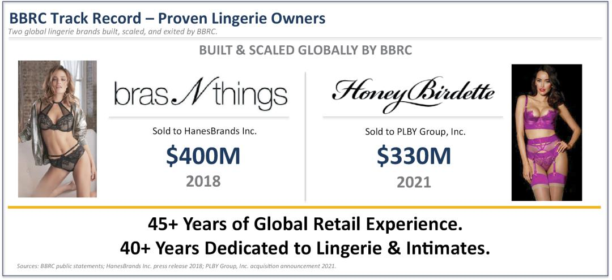

We invest to build durable value, not to react to short-term movements in a company’s stock price or pursue transient outcomes. Specifically:

- We are long-term investors — we began investing in Victoria’s Secret four years ago and expect to remain engaged for years to come.

- We have a proven track record of creating value in the lingerie specialty category.

- We are not activist investors — we did not approach our investment in Victoria’s Secret with the intention of seeking control or risking disruption with a broad governance campaign; this solicitation is designed to minimize disruption by focusing solely on accountability for just one problematic director.

Following our due diligence during the strategic review process that preceded Victoria’s Secret’s separation from L Brands in 2021, we elected to invest with other stockholders in the Company’s common shares. Our investment expanded over time. Today, we have purchased almost 1,500 times the shares purchased by the entire Board of Directors,¹ and our approximately 13.0% ownership position reflects both our long-term orientation and our conviction in the enduring strength of the Victoria’s Secret brand.

____________

- Form 3 and Form 4 filings by directors of the Company

15

SUPPORTING THE TURNAROUND AT VICTORIA’S SECRET REQUIRES VOTING AGAINST THE CHAIR THAT NECESSITATED IT

Over the duration of our investment, VSCO has underperformed its self-selected peer group, the S&P 500 Consumer Discretionary Distribution & Retail Index, by approximately 92 percentage points – at its worst, VSCO had returned 145% less than its benchmark.² The recent share price performance does not eliminate the need to hold the Board accountable for years-long weakness in governance and oversight.
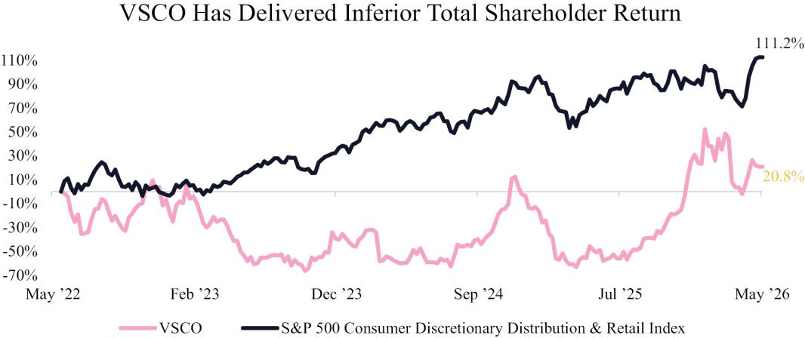

We believe a significant driver of this underperformance is the Board’s ineffective oversight of management, including the misallocation of approximately $1.2 billion to poorly executed buybacks and M&A with little demonstrable return.
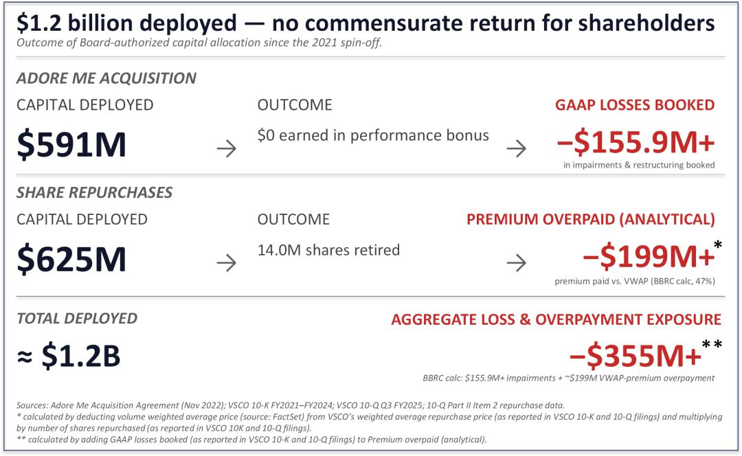

____________

- FactSet. Total stockholder return measured from May 20, 2022 (the date of BBRC share purchases that required its Schedule 13G filing) through May 1, 2026. The S&P 500 Consumer Discretionary Distribution & Retail Index is the peer group used by the Company in its 2025 proxy statement to calculate its relative total stockholder return.

16

In our view, change is needed to the VSCO Board of Directors because the Chair of the Board has overseen Victoria’s Secret for 25 years and excessive director tenure is inconsistent with effective corporate governance. That perspective is widely held: more than 75% of S&P 500 companies with director tenure limits cap service at 15 years or less,³ and the CEO of the National Association of Corporate Directors has recommended a 10-year limit for public company directors.⁴ Unfortunately, we believe that the Board’s delayed transition away from the prior CEO and strategy it had endorsed confirms that the reduced independence commonly associated with excessive tenure has already materialized at Victoria’s Secret, resulting in:

- years of underperformance

- substantial erosion of stockholder value, and

- the need for the current turnaround effort

This solicitation is not about revisiting the past – it is about strengthening governance and Board oversight to protect the progress currently underway at VSCO. In our view, targeted Board refreshment is necessary to support the Company’s ongoing transformation. We have engaged with the Board extensively on these issues, including the need for new leadership in the boardroom.⁵ Despite that effort, the Board has been unable to provide BBRC with a satisfactory explanation for its resistance to change and has chosen to retain Ms. James as Chair. In the face of the Board’s inaction, we have no choice but to bring this matter directly to our fellow stockholders. We are asking stockholders to hold Ms. James accountable for the documented failures of oversight and capital allocation that have occurred on her watch.

For the reasons detailed further below, we are soliciting stockholders to join us in voting AGAINST the election of Donna James, whose overly long tenure as a director and continued service as Chair, in our view, underscore the Board’s failure to refresh its leadership.

UNDER MS. JAMES, STOCKHOLDERS HAVE SUFFERED YEARS OF VALUE DESTRUCTION, MISALLOCATED CAPITAL AND ANTI-STOCKHOLDER GOVERNANCE

Excessive Tenure Leads to Weakened Objectivity: Ms. James has overseen VSCO for 25 years, including 20 years working alongside Les Wexner on the boards of Intimate Brands, The Limited and L Brands, the Company’s former parent companies. As Chair of the Audit Committee at L Brands, Ms. James was named as a defendant in stockholder derivative litigation alleging:

breaches of fiduciary duty | a pattern of sexual harassment and retaliation by
breaches of fiduciary duty | Company executives
failures of Board oversight | ties to Jeffrey Epstein


The litigation resulted in a settlement requiring $90 million in governance reforms, including reforms directed at the very committee Ms. James chaired for 15 years.⁶ These reforms required, among other things, that express oversight of ethics and compliance, quarterly compliance reporting, and annual reporting on the effectiveness of the compliance function were added to the L Brands’ Audit Committee charter.

In our view, Ms. James’ 25-year tenure is well beyond the range commonly associated with maintaining independent judgment and effective oversight in the boardroom. We believe that the negative effects of prolonged tenure on independence from management were readily visible in the Board’s hesitation to change management. After three years of declining performance, the Board belatedly replaced its CEO and CFO at the cost of approximately $13 million in severance and related expenses.⁷ The Board has taken credit for recent improvements in performance

____________

- The Conference Board. “Board Practices and Composition in the Russell 3000 and S&P 500: 2025 Edition” (November 17, 2025).
- Fortune. “How to embrace board turnover and do it the right way” (October 17, 2023).

- Donna James was a Director of Intimate Brands. as of March 23, 2001. Intimate Brands was a majority-owned subsidiary of The Limited, Inc. that was recombined with The Limited in 2002. The Limited, Inc. changed its name to Limited Brands, Inc. in May 2002 and to L Brands, Inc. in March 2013. VS separated from L Brands in August 2021. Ms. James was on the Board for the entire duration.
- Rudi v. Wexner, et al., Case No. 2:20-cv-3068 (U.S. Dist. Ct. S.D. Ohio)

7The Company’s Form 10-K for the fiscal year ended January 31, 2026

17

under CEO Hillary Super because she was appointed while Ms. James was Chair.⁸ This attribution does not alter the fact that Ms. James presided over the years of underperformance that preceded Ms. Super’s appointment, including the succession process that necessitated the current turnaround.
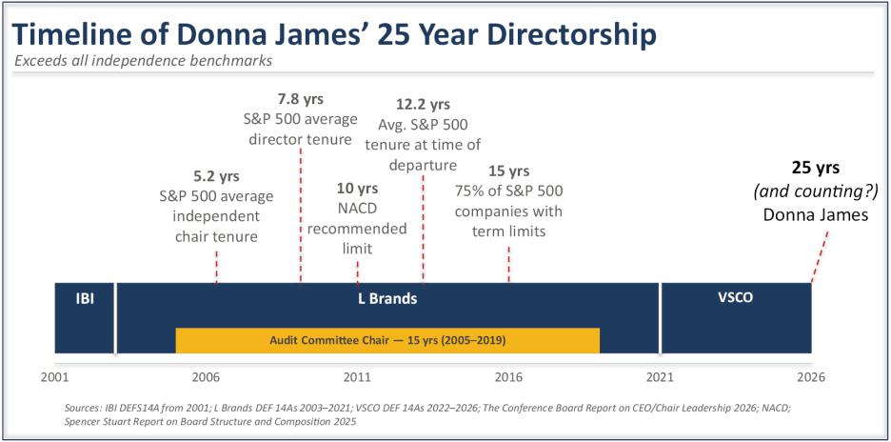

Ms. James presided as Chair over the failed strategic initiatives, outsized compensation packages and ineffective allocation of capital that led to sustained underperformance for stockholders. We believe that accountability for the years of underperformance is necessary to preserve the current momentum. Nearly five years after the Company’s separation from L Brands, the need for leadership transition at the Board level is clear. The Chair role should now pass to another director.

Months of Turnaround Do Not Make Up for Years of Underperformance: The Board has overseen a significant deterioration in VSCO’s financial performance since it spun off from L Brands and became an independent public company in August 2021.
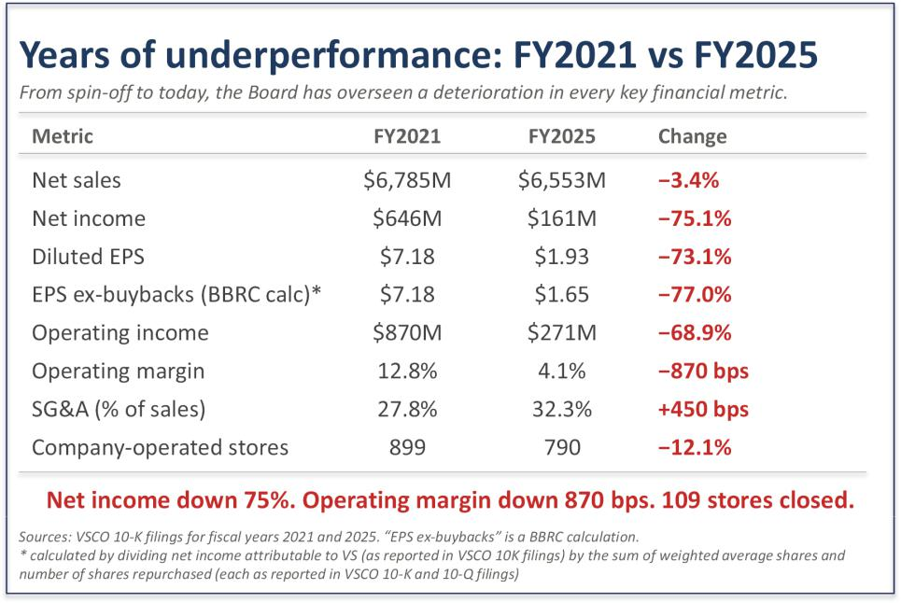

____________

- Victoria’s Secret & Co. Board Comments on BBRC Letter, November 4, 2025

18

Missed Guidance: VSCO is on track to miss the 2026 financial targets it set at its October 2023 Investor Day by a wide margin. In 2023, the Company told stockholders that it aimed to generate mid-single digit sales growth by 2026 so that it could deliver 2026 revenue of $7.4 billion. Operating margin was projected to grow to low double digits by 2026, ending between 10% and 12%.⁹ The Company’s own fiscal 2026 revenue guidance of $6.85-$6.95 billion and approximately 6.5% operating margin falls well short of both targets. The executives who were on track to miss these targets have been replaced, but the individual responsible for Board leadership throughout this period — the Chair — remains in place. We believe that the Board’s leadership should be refreshed before the Company presents new targets or updated guidance.
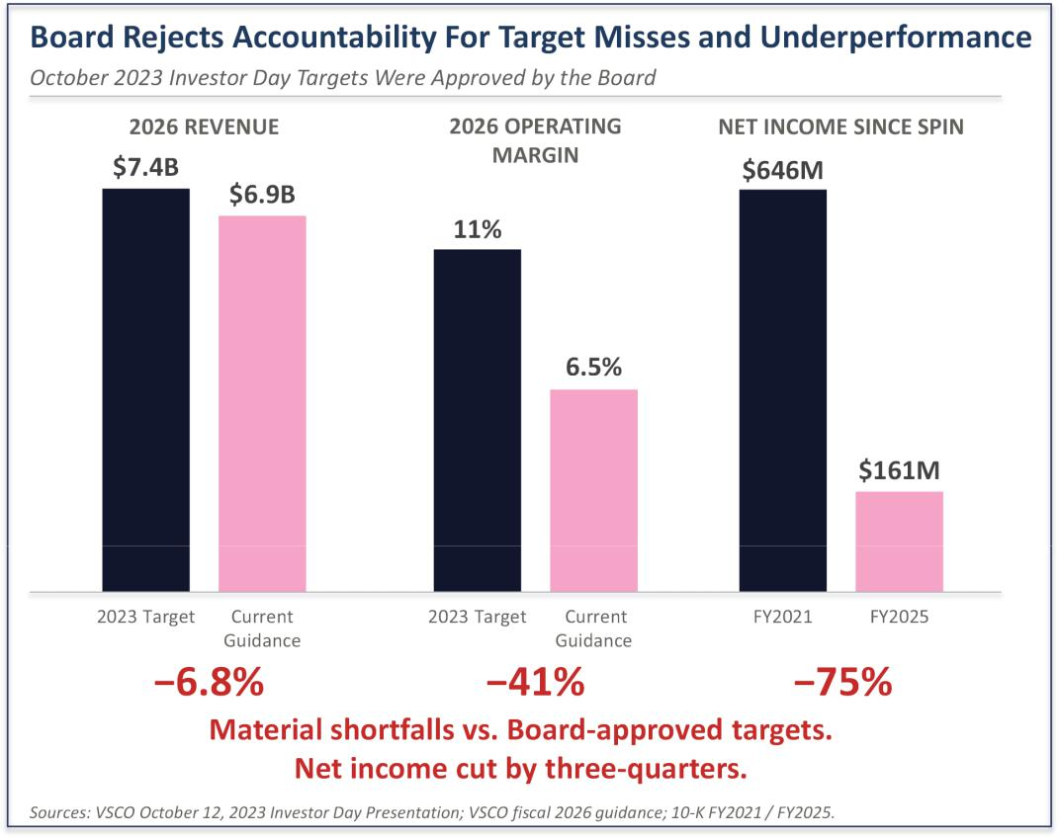

Failed Adore Me Acquisition: VSCO spent approximately $591 million¹⁰ to acquire Adore Me despite its lack of profitability and told stockholders when the deal closed in 2023 that it would be earnings and cash flow accretive that same year.¹¹ Instead, more than three years later, Adore Me has failed to meet its EBITDA and net revenue targets — with performance so underwhelming that the Company itself initially calculated that zero dollars were owed under the performance-based earnout.¹² The Company has also taken write-downs and restructuring charges against DailyLook while the search continues for its strategic purpose, and management continues to explore ways “to optimize [Adore Me] within the broader portfolio.”¹³ As further evidence of the cost to stockholders of this failed

____________

- The Company’s 2023 Investor Day Presentation

- The Company’s Form 10-K dated March 21, 2025 disclosed that the Company made an upfront cash payment of $391 million at closing and then made additional payments related to Adore Me totaling $200 million during 2024
- The Company’s press release dated January 3, 2023

- According to the Company’s Form 10-K dated March 21, 2025, the Company calculated that zero dollars were owed under the performance-based earnout. In its Form 10-K dated March 20, 2026, the Company disclosed that it made payments totaling $5 million related to the contingent payment
- The Company’s FY 2025 results press release and earnings call dated March 5, 2026

19

acquisition, the Company announced more than $155.9 million of impairments and restructuring charges for Adore Me and DailyLook in the latest fiscal quarter.¹⁴ We believe that Ms. James, as Chair of the Board, should be held accountable for this misallocation of capital and failed post-closing integration.
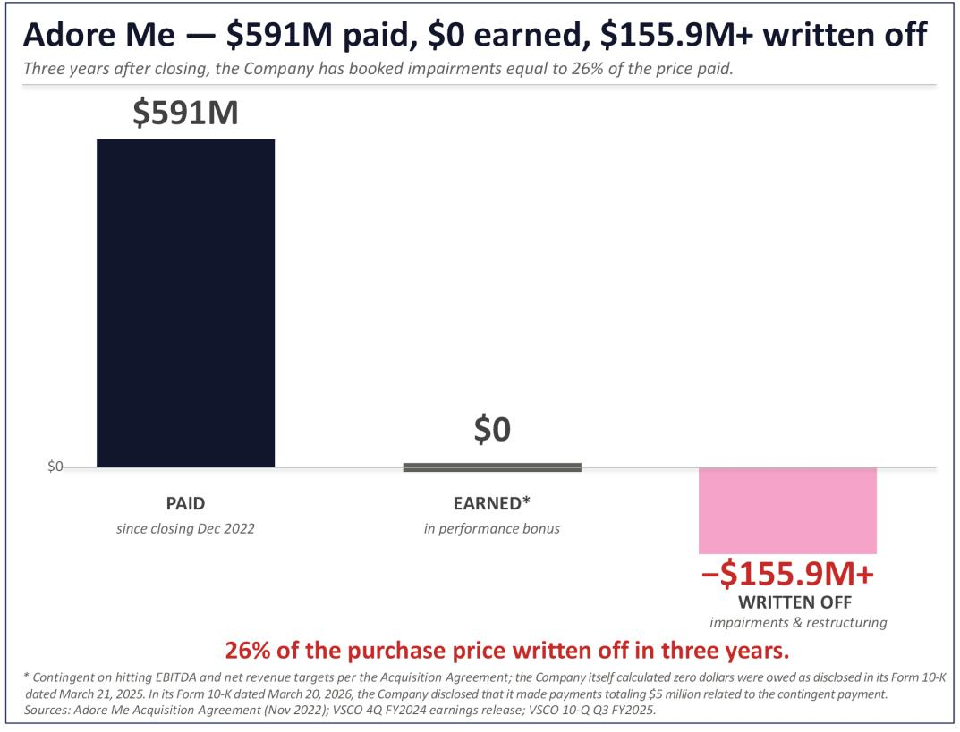

Ineffective Buyback Execution: The Board has authorized the identical amount of cash for repurchase programs with every renewal from 2021 to 2024 (totaling $1 billion authorized, of which $625 million has been spent), regardless of changes in profitability, cash flow and forecasts.¹⁵ In addition, the Board has failed to oversee the appropriate execution of these programs. VSCO’s volume-weighted average price from the L Brands separation through January 2026 was $30.34,¹⁶ but over the same time period the Company repurchased shares as part of publicly announced programs at an average price of $44.53 per share.¹⁷ In total, 14.0 million shares were repurchased at an average price that was 47% above VWAP because the Board failed to accelerate deployment of already-authorized capital as share prices fell. This is not a record of considered capital allocation — it is a record of indifference to stockholder value.

____________

- The Company’s press release dated March 5, 2026

- Company Form 8-K filings on December 29, 2021, March 2, 2022, January 11, 2023, January 31, 2023 and March 6, 2024
- FactSet

- VSCO Form 10-Q and 10-K filings, Part II Item 2 (Issuer Purchases of Equity Securities).

20

Unresponsiveness to Stockholders: Replacing the CEO in 2024 was the right decision. The question stockholders should ask is why it took this Board approximately three years and more than 70% destruction of stockholder value to reach that conclusion.
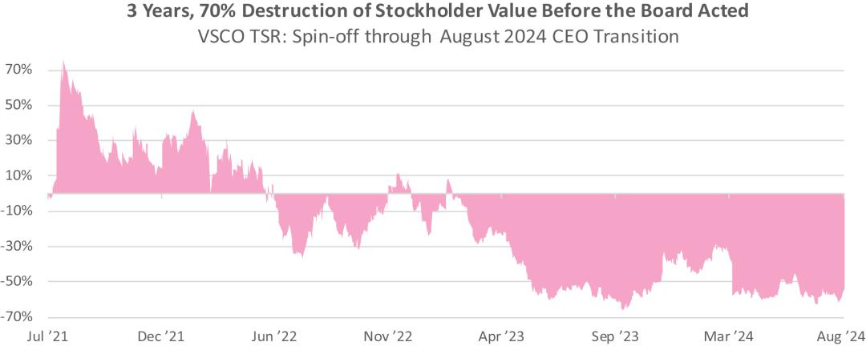

Equally concerning, given the Board’s repeated pattern of delayed corrective action, is the continuing disregard for declining stockholder support for the Company’s executive compensation structure.¹⁸
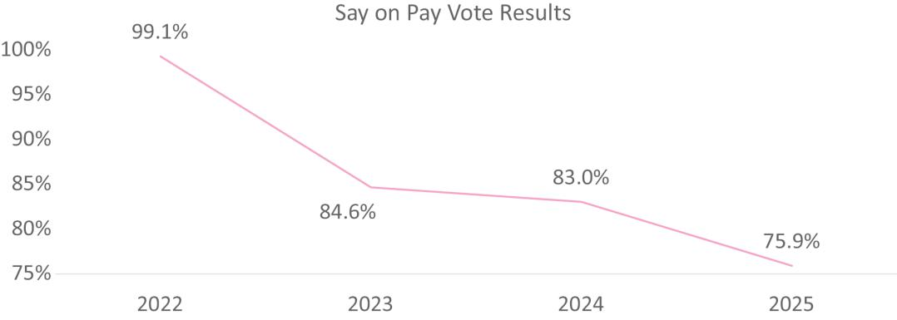

Despite the low support for executive compensation at the 2024 annual meeting, the Board did not take stockholder feedback into account and the Company’s 2025 proxy statement contained the same PSU design and the same severance provisions, plus a new discretionary modifier that further insulated management from accountability. The 2026 proxy statement exacerbates stockholder concerns, with the discretionary modifier’s metrics altered to, in BBRC’s view, less concrete factors such as “operational agility” that may already be incorporated into the executives’ regular compensation. The Board has set Fall season incentive targets below prior year actual results in three of the past four fiscal years, which progressively lowered the bar so that declining performance would still trigger above-target payouts.¹⁹ The Company uses one benchmark to report total stockholder return to its stockholders

____________

- Approximately 25% of votes cast at the 2025 Annual Meeting opposed the compensation of the Company’s named executive officers
- The Company’s proxy statements disclose that Fall season operating income targets were set below prior year actual results in fiscal year 2021, fiscal year 2022 and fiscal year 2023. Numerical analysis of the fiscal year 2024 proxy shows the Fall 2024 operating income target of $186 million was also set 9% below the Fall 2023 actual of $205 million. Over four years, the Fall operating income target declined from $475 million to $186 million – a 61% reduction – yet Fall 2024 paid out at 165.2% of target on actual operating income of $235 million, a figure that would have fallen below the minimum threshold as recently as fiscal year 2022

21

(S&P 500 Consumer Discretionary Distribution & Retail Index) and a different benchmark to determine PSU executive payouts (S&P 1500 Specialty Retail Index) — the two benchmarks produce materially different three-year results, with no disclosed rationale for the difference.
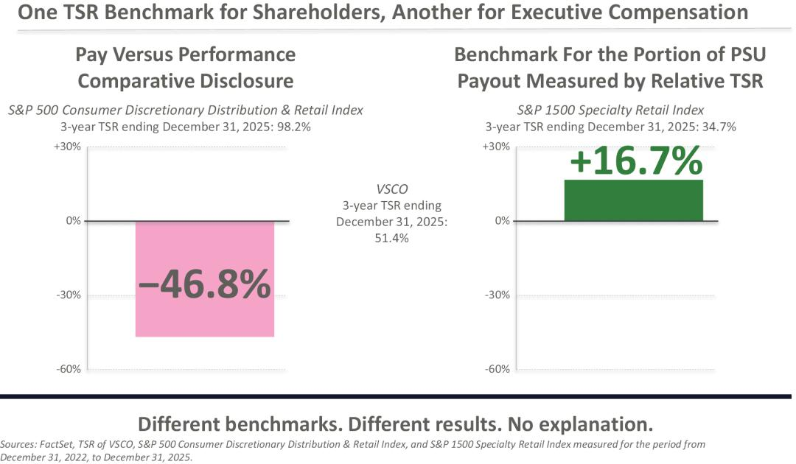

The Board’s unresponsiveness also extends to its own composition. Despite BBRC’s repeated calls for a stockholder representative on the Board, the Company’s most recent director addition was not independently sourced — the Company’s own proxy statement discloses that he was “initially identified as a potential director nominee by our CEO.”²⁰

Stockholders deserve a Board that learns from its mistakes — not one that takes credit for belatedly correcting them.

Change is Needed Because the Board Refused to Take Sufficient Steps to Address These Concerns. Contrary to the Board’s assertion that it made multiple reasonable efforts to resolve BBRC’s concerns through settlement, in fact the Board’s settlement proposal on January 9, 2026, was the third iteration of the
same settlement structure the Board has offered since January 2024.

- The Board’s initial proposal, in January 2024, was a limited information-sharing arrangement under which BBRC would have been confined to two management briefings over one year, with no new director, no capital allocation review, and no governance changes. That proposal was conditioned on BBRC agreeing, among other standstill restrictions, not to nominate any candidates at VSCO’s 2024 annual meeting of stockholders.

- After BBRC continued to raise its concerns publicly through 2025, the Board tweaked its proposal in December 2025 to add one mutually agreed independent director, a capital allocation review, and withdrawal of the poison pill. This revision remained subject to BBRC agreeing to a standstill which would restrict our ability to engage with stockholders and the Board.

- On January 9, 2026, the Board repeated the December 2025 framework without any material modification.

____________

- The Company’s 2025 proxy statement (filed April 28, 2025), p.21

22

Across three iterations and twenty-two months, the Board has not addressed the core concerns of BBRC and, presumably, other stockholders. The “mutually agreed” director construct gives the Board a practical veto over the profile and independence of any new director, while leaving the Chair position and the Board composition that approved the Adore Me acquisition unchanged. The capital allocation review proposed by the Company remains undefined in scope, leadership, timeline, or deliverable.

At no point during our engagement has the Board acknowledged the validity of the question of Chair succession or the inappropriateness of the Chair’s 25-year tenure. The Board has been willing to offer process — information sharing, a capital allocation review, and even withdrawal of the rights plan — but has been silent on the central governance question BBRC has raised. Although the Board could have responded substantively and avoided this proxy contest, it has instead opted to saddle stockholders with the cost of advisory and legal fees, as well as the risk of management distraction.
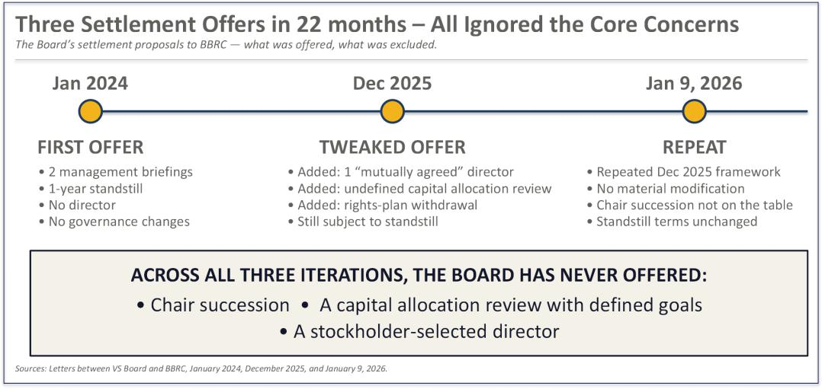

Poison Pill and Other Anti-Stockholder Governance: Following BBRC’s private expression of concerns about the Company’s strategy, governance and performance, the Board unilaterally adopted a restrictive poison pill without submitting it to stockholders for approval. According to the Company’s proxy statement, the Board has determined not to extend its poison pill. BBRC believes that the Board has tacitly acknowledged that its stockholder rights plan was out of step with governance best practices and stockholders’ best interests.

The Company’s non-executive directors collectively own 0.3% of the Company’s outstanding shares of Common Stock, approximately 97% of which was received through Company grants rather than personal investment. By contrast, BBRC has acquired almost 1,500 times the shares purchased by the entire Board. We believe the Board’s limited economic exposure has created a divergence with independent stockholders — a dynamic that may help explain the Board’s defensive posture toward BBRC, including its mischaracterization of our intentions as a significant stockholder.

Taken together with the Board’s tolerance of excessive tenure, defensive reaction to BBRC’s concerns, and failure to meaningfully respond to declining shareholder support for executive compensation, we believe that stockholders must act to reset governance at VSCO.

23

THE UPCOMING ANNUAL MEETING IS AN OPPORTUNITY TO UPGRADE THE BOARD BY VOTING AGAINST MS. JAMES

VSCO’s director resignation policy, which requires the Board to determine whether to accept the resignation of any director who fails to receive majority support for his or her election, empowers stockholders with a clear pathway to hold directors accountable. We strongly believe that voting AGAINST Ms. James’ reelection is an exercise in “addition by subtraction”. We believe a Board without Ms. James will bring improved oversight of capital allocation, focus on the core business rather than optimizing a failed acquisition, and lead to the appointment of a new Chair with the expertise that this next phase of the turnaround demands.

If a director fails to receive a majority of the votes cast for his or her election, as a result of our proxy solicitation, then we believe it would be inappropriate for any such director to continue to serve on the Board. In our view, a failure by the Board to accept any tendered resignations resulting from the votes of stockholders at the Annual Meeting would be a serious governance failure and directly contrary to a clear stockholder mandate. The progress now underway at Victoria’s Secret does not diminish the need for accountability — it reinforces it. A Board committed to the Company’s next chapter must also reflect the lessons of the last one.

Ms. Super is building a new VSCO. She deserves a Board that matches her ambition and brings fresh judgment, governance discipline, and stronger oversight to the boardroom. The Annual Meeting is an opportunity to support that future by voting AGAINST Ms. James, whose 25-year tenure as director and continued service as Chair exemplifies the Board’s failure to refresh its leadership. This change is not intended to disrupt the turnaround - it is intended to strengthen it.

24

PROPOSAL 1 — ELECTION OF DIRECTORS

As disclosed in the Company’s proxy statement, the Board is currently composed of ten directors and each director is elected annually to serve a one-year term. The Company has announced that Mariam Naficy will no longer stand for re-election at the Annual Meeting, and the size of the Board will be reduced from ten to nine members effective at the Annual Meeting. At the Annual Meeting, stockholders will be asked to elect nine

- directors to serve until the next annual meeting of stockholders and their successors are duly elected and qualified, or until their earlier resignation, removal or death. For the reasons described in this Proxy Statement, BBRC is soliciting your support to vote “AGAINST” the election of Donna James. BBRC is not nominating an alternative slate of directors and, accordingly, the election of directors at the Annual Meeting is expected to be an uncontested election. The Company has adopted a majority of votes cast standard for the election of directors for uncontested elections. Since we are not proposing an alternate slate of directors, the election is considered to be uncontested despite our opposition to one of the Company Nominees. Pursuant to the Second Amended and Restated Bylaws of Victoria’s Secret (the “Bylaws”), each director nominee must receive a majority of votes cast with respect such nominee’s election in order to be elected. A “majority of votes cast” means that the nominee received more votes “FOR” his or her election than “AGAINST” his or her election.

The Bylaws further provide that, in order to be eligible for nomination, each incumbent director must submit an irrevocable resignation in advance of the election, and each non-incumbent nominee must commit to tendering such a resignation promptly upon election. In either case, the resignation becomes effective only upon two conditions being met: (i) the director fails to receive a majority of votes cast in an uncontested election, and

- the Board accepts the resignation in accordance with its applicable policies and procedures. If an incumbent director does not receive a majority of votes cast in an uncontested election, the Nominating and Governance Committee will then recommend to the Board whether to accept or reject the tendered resignation, and the Board will determine whether to accept such resignation or whether to take other action. The Board is required to act on such resignation no later than its first regularly scheduled meeting following certification of the stockholder vote, and in making its determination, the Board may consider any factors or information it deems appropriate or relevant.

Any director whose resignation is under consideration must abstain from participating in any decision regarding such resignation. If necessary, the Board will appoint a committee of independent directors to evaluate the resignation and make a recommendation. If the Board accepts a resignation, it may fill the resulting vacancy or reduce the size of the Board.

Accordingly, if stockholders vote “AGAINST” the election of Donna James and she fails to receive the required majority of votes cast at the Annual Meeting, her resignation will be considered by the Board as described above. Even in that circumstance, the remaining Company Nominees, if elected, will constitute a majority of the Board, and the Board will retain the authority, consistent with its governing documents and fiduciary duties, to determine whether to accept or reject any such resignation and to address any resulting vacancy.

Notwithstanding the foregoing, and for all of the reasons set forth in this Proxy Statement, BBRC urges stockholders to vote “AGAINST” the election of Donna James at the Annual Meeting.

This Proxy Statement and the enclosed GOLD proxy card provide stockholders with the ability to vote with respect to all Company Nominees, including Donna James, Irene Chang Britt, Sarah Davis, Jacqueline Hernández, Rod Little, David McCreight, Lauren Peters, Anne Sheehan and Hillary Super. The Company Nominees are not nominees of BBRC and are not participants in this solicitation. We can provide no assurance that any of the Company Nominees will serve as directors if elected. The names, backgrounds, qualifications and other information regarding the Company’s nominees are set forth in the Company’s proxy statement.

IF YOU MARK FEWER THAN A TOTAL OF NINE (9) “FOR,” “AGAINST” OR “ABSTAIN” BOXES WITH RESPECT TO THE ELECTION OF DIRECTORS, YOUR SHARES WILL ONLY BE VOTED WITH RESPECT TO THE NOMINEES YOU HAVE SO MARKED, IN THE MANNER YOU HAVE DIRECTED.

25

BBRC STRONGLY URGES YOU TO VOTE “AGAINST” THE ELECTION OF THE OPPOSED COMPANY NOMINEE, DONNA JAMES, ON THE ENCLOSED GOLD PROXY CARD AND

INTENDS TO VOTE ITS SHARES “AGAINST” MS. JAMES’ ELECTION.

BBRC MAKES NO RECOMMENDATION WITH RESPECT TO THE ELECTION OF THE UNOPPOSED COMPANY NOMINEES AND INTENDS TO VOTE ITS SHARES “FOR” THE

UNOPPOSED COMPANY NOMINEES.

26

PROPOSAL 2 — ADVISORY APPROVAL OF COMPENSATION OF NAMED EXECUTIVE OFFICERS

As discussed in further detail in the Company’s proxy statement, Section 14A of the Exchange Act requires public companies to provide their stockholders with the opportunity to express their view on the compensation of their named executive officers. At the Company’s annual meeting of stockholders in 2022, a majority of stockholders voted, consistent with the recommendation of the Board, to hold an annual stockholder advisory vote to approve the compensation of the Company’s named executive officers (commonly known as a “say-on-pay” vote). This annual say-on-pay vote will continue unless stockholders vote at the Company’s annual meeting of stockholders in 2028, to approve a different frequency of say-on-pay voting.

At the Annual Meeting, the Board is asking stockholders to approve, on an advisory basis, the compensation of the Company’s named executive officers as described in the Company’s proxy statement. This proposal gives stockholders the opportunity to express their views on the Company’s executive compensation. The vote is not intended to address any specific item of compensation, but rather the overall compensation of the Company’s named executive officers and the compensation philosophy, policies and practices described in the Company’s proxy statement.

Although the vote on this proposal is advisory and non-binding, the Company has indicated in previous years that the Board and the Human Capital and Compensation Committee of the Board will consider the results of this vote and, if there is a significant number of negative votes, will seek to understand the concerns that influenced those votes and take them into account in making future decisions regarding the Company’s executive compensation program. Although 25% of voting shareholders opposed the compensation plan at the 2025 annual meeting, the executive compensation program is largely unchanged.

One of BBRC’s principles of ownership is that compensation must be structured to encourage management teams to operate with an ownership mindset.

In addition to the concerns described in this Proxy Statement regarding Board oversight, accountability and alignment with stockholder interests, BBRC does not believe it is appropriate to support this proposal because of the following flaws in the Company’s executive compensation program:

- Misalignment with operating performance: Although 2025 GAAP operating income declined 13% and GAAP EPS declined 6% from the prior year, the proxy statement reports that payouts to named executive officers were weighted 154% of target in fiscal 2025, an increase from 126% in fiscal 2024.

• Strategic modifier became more subjective and paid out at the maximum: The proxy

statement discloses that the 2025 strategic modifier was based on “Mitigating Tariff Impact” and “Strategic Change Leadership.” The Board awarded the maximum 15% modification based on partial mitigation of $45 million of the Company’s $130 million tariff impact and factors like “organizational agility” that may already be incorporated into the executives’ regular compensation. It is notable that the evaluated factors for the 2025 modifier are, in BBRC’s view, less concrete than those in 2024 (loyalty program, product lead-time reduction, and infrastructure investment), and that more of the modifier was awarded this year than the 9% that was applied last year.

- Lower targets for maximum PSU payout: The 2025 maximum payout hurdle was lowered to 15% operating income CAGR, compared to 20% operating income CAGR in 2024. We believe that lowering the maximum hurdle, despite stronger 2025 momentum, raises questions about the process by which the compensation goals are set.

- Easier relative TSR benchmark:The Company’s Pay Versus Performance Comparative Disclosure compares Victoria’s Secret’s TSR performance to the S&P 500 Consumer Discretionary Distribution & Retail Index.²¹ However, the Company uses a different benchmark, the S&P 1500 Specialty Retail Index, to assess three-year relative total shareholder return for determining PSU
payout.²² The Company does not
____________

- Victoria’s Secret 2026 Proxy Statement pg. 70

- Victoria’s Secret 2026 Proxy Statement pg. 53

27

disclose its rationale for using two different benchmarks for similar TSR comparisons. By comparing TSR to the S&P 1500 Specialty Retail Index, the Board is able to reward executives for 16.7% outperformance instead of negative 46.8% underperformance:

 | 3-Year TSR |  | TSR since Spin
 | (12/31/22 – 12/31/25)²³ |  | (7/22/21 – 5/1/26)²⁴
VSCO | 51.4% |  | 28.0%
S&P 500 Consumer Discretionary Distribution & Retail Index | 98.2% |  | 47.4%
S&P 1500 Specialty Retail Index | 34.7% |  | 34.4%
Relative Performance:
VSCO vs. S&P 500 CDD&R | -46.8% |  | -19.4%
VSCO vs. S&P 1500 SR | +16.7% |  | -6.4%

Accordingly, BBRC recommends that stockholders vote “AGAINST” the advisory approval of the compensation of the Company’s named executive officers.

BBRC RECOMMENDS THAT STOCKHOLDERS VOTE “AGAINST” THE APPROVAL, ON AN ADVISORY BASIS, OF THE COMPENSATION OF THE COMPANY’S NAMED EXECUTIVE OFFICERS AND INTENDS TO VOTE ITS SHARES “AGAINST” THIS PROPOSAL.

____________

- FactSet.

- FactSet.

28

PROPOSAL 3 — RATIFICATION OF APPOINTMENT OF INDEPENDENT REGISTERED PUBLIC ACCOUNTING FIRM

As disclosed in the Company’s proxy statement, the Audit Committee of the Board has approved the engagement of Ernst & Young LLP as the Company’s independent registered public accounting firm and to perform the audit of the Company’s financial statements and internal control over financial reporting for the fiscal year ending January 30, 2027 and is submitting its appointment to stockholders for ratification.

According to the Company’s proxy statement, representatives of Ernst & Young LLP are expected to be present at the Annual Meeting to respond to relevant questions from stockholders and will have an opportunity to make a statement if they so choose.

WE MAKE NO RECOMMENDATION WITH RESPECT TO THE RATIFICATION OF THE

APPOINTMENT OF ERNST & YOUNG LLP AS THE COMPANY’S INDEPENDENT REGISTERED PUBLIC ACCOUNTING FIRM FOR FISCAL YEAR 2026 AND INTEND TO VOTE OUR SHARES “FOR” THIS PROPOSAL.

29

VOTING AND PROXY PROCEDURES

Stockholders are entitled to one vote for each share of Common Stock held of record on the Record Date with respect to each matter to be acted upon at the Annual Meeting. Only stockholders of record at the close of business on the Record Date will be entitled to notice of and to vote at the Annual Meeting. Stockholders who sell their shares of Common Stock before the Record Date (or acquire them after the Record Date without voting rights) will not be entitled to vote such shares. Stockholders of record on the Record Date will retain their voting rights in connection with the Annual Meeting even if they sell such shares after the Record Date. Based on publicly available information, BBRC believes that the Common Stock is the only class of securities of the Company entitled to vote at the Annual Meeting.

Shares of Common Stock represented by properly executed GOLD proxy cards will be voted at the Annual Meeting as marked. In the absence of specific instructions, such shares will be voted “AGAINST” the election of the Opposed Company Nominee, “FOR” the election of the Unopposed Company Nominees, “AGAINST” the advisory approval of the compensation of the Company’s named executive officers, and “FOR” the ratification of the appointment of Ernst & Young LLP as the Company’s independent registered public accounting firm for the fiscal year ending January 30, 2027.

This Proxy Statement and the enclosed GOLD proxy card provide stockholders with the ability to vote with respect to all Company Nominees, including Donna James, Irene Chang Britt, Sarah Davis, Jacqueline Hernández, Rod Little, David McCreight, Lauren Peters, Anne Sheehan and Hillary Super. The Company Nominees are not nominees of BBRC and are not participants in this solicitation. The names, backgrounds, qualifications and other information regarding the Company Nominees are set forth in the Company’s proxy statement. We can provide no assurance that any of the Company Nominees will serve as directors if elected.

If you properly execute and return the enclosed GOLD proxy card, your shares will be voted at the Annual Meeting in accordance with your instructions. An “undervote” occurs when you return a valid GOLD proxy card but do not indicate a vote for one or more of the nominees or proposals.

IF YOU MARK FEWER THAN A TOTAL OF NINE (9) “FOR,” “AGAINST” OR “ABSTAIN” BOXES WITH RESPECT TO THE ELECTION OF DIRECTORS, YOUR SHARES WILL ONLY BE VOTED WITH RESPECT TO THE NOMINEES YOU HAVE SO MARKED, IN THE MANNER YOU HAVE DIRECTED.

In the election of directors, you may vote “FOR” or “AGAINST” or “ABSTAIN” with respect to each of the nine (9) Company Nominees. If you mark both “FOR” and “AGAINST” or “FOR” and “ABSTAIN” or “AGAINST” and “ABSTAIN” with respect to the same nominee, or otherwise mark more selections than permitted, your vote with respect to that nominee will not be counted.

In the event that BBRC abandons its solicitation or does not solicit the requisite number of holders of the Company’s outstanding Common Stock, BBRC will, with respect to any votes cast on the enclosed GOLD proxy card, submit such votes to the independent inspector.

We urge you to carefully follow the instructions on the enclosed GOLD proxy card to ensure that your shares are voted in accordance with your intentions.

30

VIRTUAL MEETING

The Company has disclosed that the Annual Meeting will be conducted virtually via live audio webcast on June 11, 2026, at 8:30 a.m. Eastern Time. Stockholders will not be able to attend the Annual Meeting in person. You may only participate in the virtual meeting by visiting www.proxydocs.com/VSCO and using your control number found on your proxy card. To participate in the Annual Meeting, including to vote and submit questions during the meeting, you must access the meeting website at www.proxydocs.com/VSCO and enter the control number provided on your proxy card.

We encourage you to access the meeting website prior to the start time of the Annual Meeting on June 11, 2026 at 8:30 a.m. Eastern Time, and to allow sufficient time for online check-in procedures.

For additional information regarding participation in the Annual Meeting, please refer to the Company’s proxy statement.

31

QUORUM; BROKER NON-VOTES; DISCRETIONARY VOTING

A quorum is the minimum number of shares of Common Stock that must be represented at the Annual Meeting, in person or by proxy, in order to conduct business. Under the Company’s governing documents and as described in its proxy materials, the presence, in person or by proxy, of stockholders of record holding at least one third of the outstanding shares of Common Stock will constitute a quorum. Once a quorum is present, the stockholders present at the Annual Meeting may continue to conduct business until adjournment, even if sufficient shares to maintain a quorum are no longer present.

Abstentions and broker non-votes will be counted as present for purposes of determining whether a quorum is present. A “broker non-vote” occurs when a broker, bank or other nominee holding shares for a beneficial owner does not receive voting instructions from such beneficial owner and does not have discretionary authority to vote on a particular proposal. Based on information contained in the Company’s proxy statement, brokers will not have discretionary authority to vote on any of the proposals at the Annual Meeting, including the ratification of independent registered public accounting firm (Proposal 3), to the extent your bank, broker or other nominee has forwarded you our proxy materials.

If you are a stockholder of record, your shares will be counted toward a quorum only if you submit a valid proxy or vote your shares at the Annual Meeting. If you are a beneficial owner and your shares are held in the name of a broker, bank or other nominee, your shares will be counted toward a quorum if your broker, bank or other nominee submits a proxy representing your shares, whether or not you provide voting instructions.

If you receive proxy materials from both the Company and BBRC and do not provide voting instructions to your broker, bank or other nominee, your shares will not be voted on any of the proposals at the Annual Meeting. Accordingly, we strongly urge you to provide voting instructions to your broker, bank or other nominee to ensure that your shares are represented at the Annual Meeting and voted in accordance with your preferences.

32

VOTES REQUIRED FOR APPROVAL

Election of Directors — The Company has adopted a majority of votes cast standard for uncontested elections of directors. Because BBRC is not proposing an alternative slate of directors, the election of directors at the Annual Meeting is expected to be an uncontested election notwithstanding our opposition to two of the Company Nominees. Under this voting standard, each director nominee must receive a majority of votes cast with respect such nominee’s election in order to be elected. A “majority of votes cast” means that the nominee received more votes “FOR” his or her election than “AGAINST” his or her election. The Company has indicated that abstentions and broker non-votes are not considered votes cast and, therefore, will have no effect on the outcome of the election of directors. Cumulative voting is not permitted.

Advisory Vote on Executive Compensation — According to the Company’s proxy statement, votes cast “FOR” this proposal must exceed the votes cast “AGAINST” this proposal to approve the compensation of the Company’s named executive officers. The Company has indicated that abstentions and broker non-votes are not considered votes cast and therefore will have no effect on the outcome of this vote.

Ratification of the Appointment of Independent Auditor — According to the Company’s proxy statement, the ratification of the selection of Ernst & Young LLP requires that the votes cast “FOR” this proposal must exceed the votes cast “AGAINST” it. The Company has indicated that abstentions and broker non-votes are not considered votes cast and therefore will have no effect on the outcome of this vote.

If you sign and submit your GOLD proxy card without specifying how you would like your shares to be voted, your shares will be voted “AGAINST” the election of the Opposed Company Nominee, “FOR” the election of the Unopposed Company Nominees, “AGAINST” the advisory approval of the compensation of the Company’s named executive officers, and “FOR” the ratification of the appointment of Ernst & Young LLP as the Company’s independent registered public accounting firm for the fiscal year ending January 30, 2027. In addition, your shares will be voted in the discretion of the persons named as proxies on any other matters that may properly come before the Annual Meeting.

33

REVOCATION OF PROXIES

Stockholders of the Company may revoke their proxies at any time prior to their exercise at the Annual Meeting. A proxy may be revoked by submitting a later-dated proxy, by delivering a written notice of revocation, or by voting virtually at the Annual Meeting. Attendance at the Annual Meeting, in and of itself, will not constitute revocation of a proxy. A properly executed proxy bearing a later date will automatically revoke any previously submitted proxy. Written notices of revocation or later-dated proxies may be delivered to BBRC, in care of Saratoga, at the address set forth on the back cover of this Proxy Statement, or to the Company at its principal executive offices or such other address as the Company may specify. Although a revocation is effective if delivered to the Company, we request that copies of all revocations be sent to BBRC, in care of Saratoga, at the address set forth on the back cover of this Proxy Statement so that we will be aware of revocations and can more accurately determine the status of proxies received from stockholders of record on the Record Date.

IF YOU WISH TO JOIN US IN VOTING “AGAINST” THE ELECTION OF THE OPPOSED COMPANY NOMINEE TO THE BOARD, PLEASE VOTE BY INTERNET OR SIGN, DATE AND RETURN PROMPTLY THE ENCLOSED GOLD PROXY CARD IN THE POSTAGE-PAID ENVELOPE PROVIDED.

34

SOLICITATION OF PROXIES

The solicitation of proxies pursuant to this Proxy Statement is being made by BBRC. Proxies may be solicited by mail, facsimile, e-mail, telephone, in person and by advertisements.

BBRC has retained Saratoga to assist in the solicitation of proxies. Saratoga will receive a fee not to exceed $125,000, together with reimbursement of its reasonable out-of-pocket expenses, and will be indemnified against certain liabilities and expenses, including certain liabilities under the federal securities laws. Saratoga will solicit proxies from individuals, brokers, banks, nominees and other institutional holders. BBRC has requested that banks, brokerage houses and other custodians, nominees and fiduciaries forward all solicitation materials to the beneficial owners of the shares of Common Stock they hold of record, and BBRC will reimburse such record holders for their reasonable out-of-pocket expenses in doing so. In addition, certain directors, officers and employees of BBRC may solicit proxies in the ordinary course of their activities without additional compensation. It is anticipated that Saratoga will employ approximately 20 persons to assist in the solicitation of proxies. Saratoga will solicit proxies by mail, telephone, facsimile or email.

The entire expense of this solicitation is being borne by BBRC. The total cost of this solicitation is currently estimated to be approximately $7,000,000, including fees for attorneys, proxy solicitors and other advisors and other costs incidental to the solicitation. BBRC estimates that its expenses in connection with this solicitation to date are approximately $1,500,000. BBRC may seek reimbursement of these expenses from the Company; however, BBRC does not intend to submit the question of such reimbursement to a vote of the Company’s stockholders.

35

ADDITIONAL PARTICIPANT INFORMATION

The participants in this solicitation are BBRC International PTE Limited (“BBRC International”), BBFIT Investments Pte Ltd (“BBFIT”), The BB Family International Trust (the “BB Family Trust”) and Brett Blundy (each, a “Participant” and collectively, the “Participants”).

BBFIT is a Singapore private limited company, the principal business of which is investing in securities. The BB Family Trust is a trust organized under the laws of Singapore and is the sole shareholder of BBFIT. BBRC International is a Singapore private limited company that serves as the trustee of the BB Family Trust. Brett Blundy is a citizen of Australia and is the sole shareholder and a director of BBRC International and a director of BBFIT. The address of the principal office of each of the Participants is 3 Phillip Street #9-05, Royal Group Building, Singapore 048693.

As of the date hereof, the Participants beneficially own in the aggregate 10,310,631 shares of Common Stock. BBFIT directly beneficially owns 10,310,531 shares of Common Stock. The BB Family Trust directly beneficially owns 100 shares of Common Stock and, as the sole shareholder of BBFIT, may be deemed to beneficially own the shares held by BBFIT. BBRC International, as trustee of the BB Family Trust, may be deemed to share voting and dispositive power with respect to the shares held by the BB Family Trust and BBFIT. Mr. Blundy, as the sole shareholder and a director of BBRC International, may be deemed to share voting and dispositive power with respect to such shares. The Participants may be deemed to constitute a “group” for purposes of Section 13(d)(3) of the Exchange Act. Each Participant disclaims beneficial ownership of any shares of Common Stock that he or it does not directly own.

The shares of Common Stock beneficially owned by the Participants were acquired with working capital (which may, at any given time, include margin loans made by brokerage firms in the ordinary course of business). Information regarding transactions in the securities of the Company by the Participants during the past two years is set forth in Schedule I and is incorporated herein by reference.

Except as otherwise set forth in this Proxy Statement (including the Schedules hereto), (i) during the past 10 years, no Participant has been convicted in a criminal proceeding (excluding traffic violations or similar misdemeanors); (ii) no Participant directly or indirectly beneficially owns any securities of the Company;

- no Participant owns any securities of the Company which are owned of record but not beneficially; (iv) no Participant has purchased or sold any securities of the Company during the past two years; (v) no part of the purchase price or market value of the securities of the Company owned by any Participant is represented by funds borrowed or otherwise obtained for the purpose of acquiring or holding such securities; (vi) no Participant is, or within the past year was, a party to any contract, arrangements or understandings with any person with respect to any securities of the Company, including, but not limited to, joint ventures, loan or option arrangements, puts or calls, guarantees against loss or guarantees of profit, division of losses or profits, or the giving or withholding of proxies; (vii) no associate of any Participant owns beneficially, directly or indirectly, any securities of the Company; (viii) no Participant owns beneficially, directly or indirectly, any securities of any parent or subsidiary of the Company; (ix) no Participant or any of his or its associates or immediate family members was a party to any transaction, or series of similar transactions, since the beginning of the Company’s last fiscal year, or is a party to any currently proposed transaction, or series of similar transactions, to which the Company or any of its subsidiaries was or is to be a party, in which the amount involved exceeds $120,000;

- no Participant or any of his or its associates has any arrangement or understanding with any person with respect to any future employment by the Company or its affiliates, or with respect to any future transactions to which the Company or any of its affiliates will or may be a party; (xi) no Participant has a substantial interest, direct or indirect, by securities holdings or otherwise in any matter to be acted on at the Annual Meeting;

- no Participant holds any positions or offices with the Company; (xiii) no Participant has a family relationship with any director, executive officer, or person nominated or chosen by the Company to become a director or executive officer; (xiv) no companies or organizations, with which any of the Participants has been employed in the past five years, is a parent, subsidiary or other affiliate of the Company; and (xv) there are no material proceedings to which any Participant or any of his or its associates is a party adverse to the Company or any of its subsidiaries or has a material interest adverse to the Company or any of its subsidiaries.

36

OTHER MATTERS AND ADDITIONAL INFORMATION

BBRC is not aware of any other matters to be brought before the Annual Meeting. However, if other matters, which BBRC is not aware of a reasonable time before this solicitation, are properly brought before the Annual Meeting, the persons named as proxies on the enclosed GOLD proxy card will vote on such matters in their discretion.

Some banks, brokers and other nominee record holders may participate in the practice of “householding” proxy statements and annual reports. This means that only one copy of this Proxy Statement may have been sent to multiple stockholders in your household. We will promptly deliver a separate copy of this Proxy Statement to you upon written request to our proxy solicitor, Saratoga, at the address set forth on the back cover of this Proxy Statement, or by calling Saratoga toll-free at (888) 368-0379. If you wish to receive separate copies of our proxy materials in the future, or if you are currently receiving multiple copies and would prefer to receive only one copy for your household, you should contact your bank, broker or other nominee record holder, or Saratoga at the address or telephone number set forth above.

The information concerning the Company and the proposals described in the Company’s proxy statement contained in this Proxy Statement has been taken from, or is based upon, publicly available documents filed with the SEC and other publicly available information. Although BBRC has no knowledge that would indicate that statements relating to the Company contained in this Proxy Statement, based upon publicly available information, are inaccurate or incomplete, BBRC has not had access to the books and records of the Company, was not involved in the preparation of such information and is not in a position to verify such information. All information relating to persons other than the Participants is given only to the knowledge of BBRC.

This Proxy Statement is dated May [•], 2026. You should not assume that the information contained in this Proxy Statement is accurate as of any date other than such date, and the mailing of this Proxy Statement shall not create any implication to the contrary.

37

SHAREHOLDER PROPOSALS

According to the Company’s proxy statement for the Annual Meeting, if a stockholder intends to present a proposal at the 2027 annual meeting of stockholders and desires to have the Company include that proposal in its proxy statement and form of proxy for that meeting under Rule 14a-8 under the Exchange Act, then the stockholder must submit the proposal in writing to the Company at its principal executive offices by January 1, 2027.

According to the Company’s proxy statement, if a stockholder wants to nominate a person for election as director or propose other business to be considered at an annual meeting of stockholders (but not for inclusion in the Company’s proxy materials), the stockholder must follow procedures outlined in the Bylaws. Under the Bylaws, stockholders of record are able to nominate persons for election as a director or submit other proposals constituting a proper matter for stockholder action by providing proper written notice to the Company’s Corporate Secretary at VSCO’s principal executive offices. As set forth in the Company’s proxy statement, proper notice generally must be received not less than 90 days nor more than 120 days prior to the first anniversary date of the annual meeting for the preceding year. To be considered timely for the 2027 annual meeting of stockholders, proper notice must be delivered no earlier than February 11, 2027 and no later than March 13, 2027. However, if the date of the 2027 annual meeting is advanced by more than 30 days prior to the first anniversary date of the Annual Meeting or delayed more than 90 days after such anniversary, then to be timely, proper notice must be received no earlier than 120 days prior to the date of the annual meeting and no later than the later of 90 days prior to the date of the meeting or the tenth day following the day on which announcement of the date of the meeting was first made. The notice must include, among other information, the name and address of the stockholder giving the notice, information about the stockholder’s ownership of Common stock, certain information relating to each person whom the stockholder proposes to nominate for election as a director, a brief description of any business the stockholder proposes to bring before the meeting and the reasons for bringing such proposal. In addition to satisfying the requirements under the Bylaws, including the notice deadlines set forth above and therein, to comply with the SEC’s universal proxy rules, stockholders who intend to solicit proxies in support of director nominees other than the Board’s nominees must also comply with the additional requirements of Rule 14a-19 under the Exchange Act.

According to the Company’s proxy statement, under the Bylaws, up to 20 stockholders owning 3% or more of VSCO’s outstanding Common Stock continuously for at least three years may nominate the greater of two directors or up to 20% of the Board and include those nominees in the Company’s proxy materials provided they satisfy the requirements set forth therein. To be timely, proper notice of director nominations by stockholders that are to be included in the Company’s proxy materials must be received at the Company’s principal executive offices, addressed to: Victoria’s Secret & Co., Attn: Corporate Secretary, Four Limited Parkway, Reynoldsburg, Ohio 43068, not less than 120 days nor more than 150 days prior to the first anniversary of the date that the Company’s proxy statement was first distributed to stockholders for the immediately preceding annual meeting of stockholders. For the annual stockholder meeting in 2027, the first anniversary of the date that the Company’s proxy statement for the Annual Meeting was distributed to stockholders is May 1, 2027. Accordingly, proper notice for this purpose must be delivered to the Company at its principal executive offices no earlier than December 2, 2026 and no later than January 1, 2027.

The information set forth above regarding the procedures for submitting stockholder proposals is based on information contained in the Company’s proxy statement. The inclusion of such information in this Proxy Statement should not be construed as an admission by BBRC that such procedures are legal, valid or binding.

38

CERTAIN ADDITIONAL INFORMATION

This Proxy Statement omits certain disclosure required by applicable law that is included in the Company’s proxy statement relating to the Annual Meeting in reliance on Rule 14a-5(c) under the Exchange Act. Such omitted information includes, among other things, information concerning the Company’s directors and executive officers, executive and director compensation, committees of the Board, certain relationships and related party transactions, the Company’s independent registered public accounting firm and other matters required to be disclosed by the Company. Stockholders are directed to refer to the Company’s proxy statement for such information, including the information required by Item 7 of Schedule 14A with respect to the Company’s nominees. The Company’s proxy statement and other relevant documents are available without charge on the website of the Securities and Exchange Commission at www.sec.gov.

See Schedule II to this Proxy Statement for information regarding persons who beneficially own more than 5% of the shares of Common Stock and the ownership of Common Stock by the Company’s directors and management.

The information concerning the Company contained in this Proxy Statement and the Schedule II attached hereto has been taken from, or is based upon, publicly available documents on file with the SEC and other publicly available information. Although we have no knowledge that would indicate that statements relating to the Company contained in this Proxy Statement, in reliance upon publicly available information, are inaccurate or incomplete, to date we have not had access to the books and records of the Company, were not involved in the preparation of such information and statements and are not in a position to verify such information and statements.

Your vote is important. No matter how many or how few shares of Common Stock you own, we urge you to vote “AGAINST” the election of the Opposed Company Nominee by marking, signing, dating and returning the enclosed GOLD proxy card promptly.

BBRC International PTE Limited

May [•], 2026

39

SCHEDULE I

TRANSACTIONS IN SECURITIES OF THE COMPANY

DURING THE PAST TWO YEARS

 |  | Shares of Common Stock
Trade Date |  | Purchased/Sold |  | Nature of Transaction
April 4, 2025 |  | 212,500 |  | Purchase of Common Stock
March 28, 2025 |  | 584,000 |  | Purchase of Common Stock
March 27, 2025 |  | 124,326 |  | Purchase of Common Stock
March 26, 2025 |  | 85,145 |  | Purchase of Common Stock
March 13, 2025 |  | 49,313 |  | Purchase of Common Stock
March 12, 2025 |  | 80,328 |  | Purchase of Common Stock
March 11, 2025 |  | 480,000 |  | Purchase of Common Stock
March 10, 2025 |  | 542,000 |  | Purchase of Common Stock
March 7, 2025 |  | 496,000 |  | Purchase of Common Stock
March 6, 2025 |  | 54,000 |  | Purchase of Common Stock
 |  | 40

SCHEDULE II

The following table is reprinted from the Company’s definitive proxy statement filed with the SEC on May 1, 2026.

BENEFICIAL OWNERSHIP OF SHARES

The following table sets forth certain information regarding the beneficial ownership of the Company’s common stock as of April 15, 2026, unless otherwise noted, by (i) each person known by the Company to beneficially own more than 5% of our outstanding common stock based on publicly available information as of April 29, 2026, (ii) each of the Company’s directors, (iii) each of the Company’s named executive officers, and (iv) all of the Company’s directors and executive officers as a group.

Except as otherwise noted, each stockholder listed below has sole voting and investment power with respect to the shares beneficially owned by such person. SEC rules consider a person to be the “beneficial owner” of any securities over which the person has or shares voting power or investment power, as well as any securities that person has the right to acquire beneficial ownership of within 60 days, including through exercise of an option or similar right.

 |  | Common |  | Right to |  | Total Beneficial |  | Percent of
Name of Beneficial Owner |  | Stock |  | Acquire⁽¹⁾ |  | Ownership |  | Class⁽²⁾
5% or More Beneficial Owners
BlackRock, Inc.⁽³⁾ |  | 10,936,720 |  | — |  | 10,936,720 |  | 13.8%
BBRC International Pte Limited⁽⁴⁾ |  | 10,310,631 |  | — |  | 10,310,631 |  | 13.0%
Vanguard Portfolio Management⁽⁵⁾ |  | 4,707,006 |  | — |  | 4,707,006 |  | 5.9%
Directors and Named Executive Officers
Irene Chang Britt |  | 27,111 |  | — |  | 27,111*
Sarah Davis |  | 26,616 |  | — |  | 26,616*
Jacqueline Hernández |  | 26,616 |  | — |  | 26,616*
Donna James |  | 63,097 |  | — |  | 63,097*
Rod Little |  | 21,572 |  | — |  | 21,572*
David McCreight |  | 10,550 |  | — |  | 10,550*
Mariam Naficy |  | 22,047 |  | — |  | 22,047*
Lauren Peters |  | 27,111 |  | — |  | 27,111*
Anne Sheehan |  | 30,052 |  | — |  | 30,052*
Hillary Super |  | 51,620 |  | — |  | 51,620*
Scott Sekella |  | 4,384 |  | — |  | 4,384*
Melinda McAfee |  | 92,632 |  | — |  | 92,632*
Elizabeth Preis |  | — |  | 10,442 |  | 10,442*
Dein Boyle⁽⁶⁾ |  | 58,700 |  | — |  | 58,700*
Current directors and executive officers
as a group (13 persons)⁽⁷⁾ |  | 403,408 |  | 10,442 |  | 413,850*

____________

- Represents less than 1% of our outstanding common stock.

- Includes (i) shares subject to options that are or may become exercisable within 60 days of April 15, 2026 and (ii) shares underlying unvested restricted stock units that are scheduled to vest within 60 days of April 15, 2026.
- Percent is based on 79,425,668 shares outstanding as of April 15, 2026, and any shares that each such director or named executive officer has the right to acquire within 60 days of April 15, 2026.
- Based solely on information set forth in the Schedule 13G/A filed July 17, 2025 by BlackRock, Inc. (“BlackRock”). BlackRock reported sole voting power over 10,782,295 shares and sole dispositive power over 10,936,720 shares. BlackRock’s address is 50 Hudson Yards, New York, NY 10001.
- Based solely on information set forth in the Schedule 13D/A filed November 4, 2025 by BBFIT Investments Pte Ltd (“BBFIT”), The BB Family International Trust (the “BB Trust”), BBRC International Pte Limited (“BBRC”), and Brett Blundy (“Mr. Blundy,” and collectively with BBFIT, the BB Trust, and BBRC, the “BBRC Reporting Persons”). BBFIT reported shared voting power and shared dispositive power over 10,310,531 shares and each of the BB Trust, BBRC and Mr. Blundy reported shared voting power and shared dispositive power over 10,310,631 shares. The address of the principal office of each of the BBRC Reporting Persons is 3 Phillip Street #9-05, Royal Group Building, Singapore 048693. BBRC,

41

as trustee of the BB Trust, may be deemed to beneficially own the shares owned by BBFIT and the BB Trust, together with the shares it beneficially owns directly, and Mr. Blundy, as director and sole shareholder of BBRC, may be deemed to beneficially own the shares owned by BBFIT and the BB Trust. Each of the BBRC Reporting Persons disclaimed beneficial ownership of any shares that he or it does not directly own.

- Based solely on information set forth in the Schedule 13G filed April 29, 2026 by Vanguard Portfolio Management (“Vanguard”). Vanguard reported sole voting power over 58,197 shares and sole dispositive power over 4,707,006 shares. Vanguard’s address is 100 Vanguard Blvd., Malvern, PA 19355.
- The beneficial ownership information presented for Dein Boyle is based on information in the Company’s records as of his last day serving as an executive officer of the Company, as he is no longer required to file reports of changes in ownership of our common stock with the SEC following such date. As discussed earlier in this Proxy Statement, Dein Boyle was not employed by the Company as of April 15, 2026.
- Excludes Dein Boyle, who is a former executive officer.

42

IMPORTANT

Your vote is important. No matter how many shares of Common Stock you own, please give BBRC your proxy to vote “AGAINST” the election of Donna James, and in accordance with BBRC’s recommendations with respect to the other proposals expected to be presented at the Annual Meeting, by taking the following steps:

- SIGNING the enclosed GOLD proxy card;

- DATING the enclosed GOLD proxy card; and

- MAILING the enclosed GOLD proxy card promptly in the envelope provided (no postage is required if mailed in the United States); or

- VOTING BY INTERNET using the unique control number and following the instructions on your GOLD proxy card.

You may vote your shares virtually at the Annual Meeting. Even if you plan to attend the Annual Meeting, we recommend that you submit your GOLD proxy card via the Internet or by mail prior to the applicable deadline so that your vote will be counted if you later decide not to attend. If your shares of Common Stock are held in the name of a brokerage firm, bank or other nominee, only that institution can vote your shares, and only upon receipt of your specific instructions. Depending on your broker or custodian, you may be able to vote by telephone or by the Internet. Please refer to the enclosed voting instruction form for details. You may also vote by signing, dating and returning the enclosed voting instruction form.

If you have any questions or require any additional information concerning this Proxy Statement, please contact Saratoga at the address set forth below.
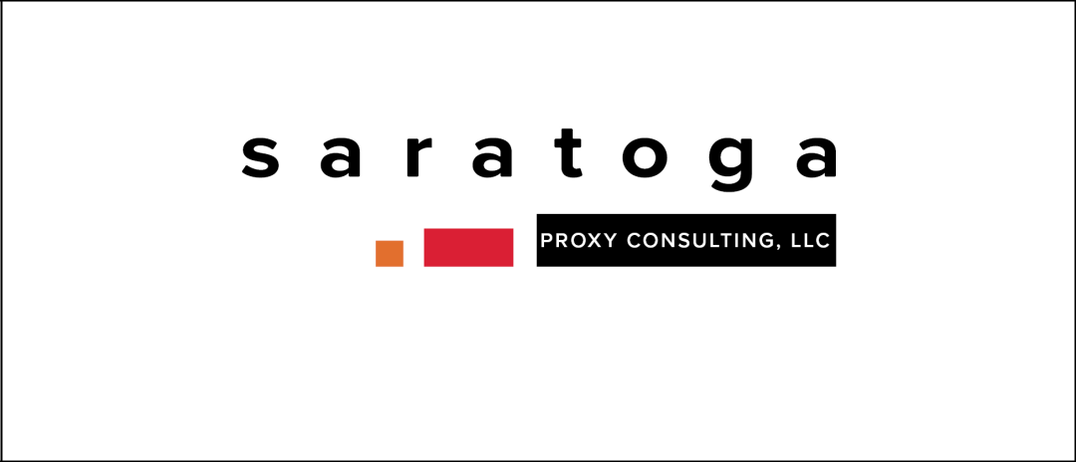

If you have any questions, require assistance in voting your GOLD proxy card, or need additional copies of BBRC’s proxy materials, please contact Saratoga at the phone numbers listed below.

520 8th Avenue, 14th Floor

New York, NY 10018

(212) 257-1311

Stockholders call toll-free at (888) 368-0379

Email: info@saratogaproxy.com

43

PRELIMINARY COPY SUBJECT TO COMPLETION

DATED MAY 19, 2026

GOLD PROXY CARD

VICTORIA’S SECRET & CO.

2026 ANNUAL MEETING OF STOCKHOLDERS

THIS PROXY IS SOLICITED ON BEHALF OF BBRC INTERNATIONAL PTE LIMITED AND THE OTHER PARTICIPANTS IN ITS SOLICITATION

THE BOARD OF DIRECTORS OF VICTORIA’S SECRET & CO.

IS NOT SOLICITING THIS PROXY

P R O X Y

The undersigned appoints Ryan Benner, John Ferguson and Richard Brand, and each of them, attorneys and agents with full power of substitution to vote all shares of common stock, par value $0.01 per share (the “Common Stock”) of Victoria’s Secret & Co. (the “Company”) which the undersigned would be entitled to vote if personally present at the 2026 annual meeting of stockholders of the Company scheduled to be held virtually (via live audio webcast) on June 11, 2026 at 8:30 a.m., Eastern Time, at www.proxydocs.com/VSCO (including any adjournments, postponements or continuations thereof and any meeting which may be called in lieu thereof, the “Annual Meeting”).

The undersigned hereby revokes any other proxy or proxies heretofore given to vote or act with respect to the shares of Common Stock held by the undersigned, and hereby ratifies and confirms all action the herein named attorneys and proxies, their substitutes, or any of them may lawfully take by virtue hereof. If properly executed, this Proxy will be voted as directed on the reverse and in the discretion of the herein named attorneys and proxies or their substitutes with respect to any other matters as may properly come before the Annual Meeting that are unknown to BBRC International PTE Limited (together with the other participants in its solicitation, “BBRC”) a reasonable time before this solicitation. Each of the proposals included on this GOLD proxy card have been proposed by the Company. None of the proposals included on this GOLD proxy card are conditioned on the approval of any other proposal.

STOCKHOLDERS ARE ADVISED THAT THE COMPANY NOMINEES ARE NOT NOMINEES OF BBRC AND ARE NOT PARTICIPANTS IN THIS SOLICITATION.

IF THIS PROXY IS SIGNED AND RETURNED, IT WILL BE VOTED AS DIRECTED. IF YOU SIGN AND RETURN AN ENTIRELY UNMARKED PROXY CARD (I.E. YOU DO NOT SPECIFY HOW THE PROXY SHOULD BE VOTED WITH RESPECT TO ANY OF THE PROPOSALS ON THE REVERSE), THIS PROXY WILL BE VOTED “AGAINST” THE ELECTION OF DONNA JAMES, “FOR” THE ELECTION OF THE REMAINING COMPANY NOMINEES, “AGAINST” PROPOSAL 2, AND “FOR” PROPOSAL 3. IF YOU SIGN AND RETURN THIS PROXY BUT ONLY PROVIDE VOTING INSTRUCTIONS WITH RESPECT TO SOME, BUT NOT ALL, OF PROPOSALS 1 THROUGH 3, YOUR PROXY WILL BE VOTED IN ACCORDANCE WITH YOUR INSTRUCTIONS ON THE PROPOSALS FOR WHICH YOU PROVIDED SPECIFIC INSTRUCTIONS, AND AS PROVIDED IN THE IMMEDIATELY PRECEDING SENTENCE WITH RESPECT TO ANY PROPOSALS FOR WHICH YOU HAVE NOT PROVIDED INSTRUCTIONS.

This Proxy will be valid until the completion of the Annual Meeting. This Proxy will only be valid in connection with BBRC’s solicitation of proxies for the Annual Meeting.

IMPORTANT: PLEASE SIGN, DATE AND MAIL THIS PROXY CARD PROMPTLY!

CONTINUED AND TO BE SIGNED ON REVERSE SIDE

GOLD PROXY CARD

[X] Please mark vote as in this example

BBRC STRONGLY RECOMMENDS THAT SHAREHOLDERS VOTE “AGAINST” THE ELECTION OF THE OPPOSED COMPANY NOMINEE AND MAKES NO RECOMMENDATION WITH RESPECT TO THE ELECTION OF THE UNOPPOSED COMPANY NOMINEES.

IF YOU MARK FEWER THAN A TOTAL OF NINE (9) “FOR,” “AGAINST” OR “ABSTAIN” BOXES WITH RESPECT TO THE ELECTION OF DIRECTORS, YOUR SHARES WILL ONLY BE VOTED WITH RESPECT TO THE NOMINEES YOU HAVE SO MARKED, IN THE MANNER YOU HAVE DIRECTED.

- To elect nine directors to the Board of Directors.

BBRC STRONGLY RECOMMENDS YOU VOTE “AGAINST” THE ELECTION OF THE FOLLOWING COMPANY NOMINEE:

COMPANY NOMINEE OPPOSED BY BBRC |  | FOR | AGAINST | ABSTAIN
A) | Donna James | ☐ | ☐ | ☐
BBRC MAKES NO RECOMMENDATION ON THE FOLLOWING EIGHT NOMINEES:
COMPANY NOMINEES UNOPPOSED BY BBRC |  | FOR | AGAINST | ABSTAIN
B) | Irene Chang Britt | ☐ | ☐ | ☐
B) | Irene Chang Britt | ☐ | ☐ | ☐
C) | Sarah Davis | ☐ | ☐ | ☐
C) | Sarah Davis | ☐ | ☐ | ☐
D) | Jacqueline Hernández | ☐ | ☐ | ☐
D) | Jacqueline Hernández | ☐ | ☐ | ☐
E) | Rod Little | ☐ | ☐ | ☐
E) | Rod Little | ☐ | ☐ | ☐
F) | David McCreight | ☐ | ☐ | ☐
F) | David McCreight | ☐ | ☐ | ☐
G) | Lauren Peters | ☐ | ☐ | ☐
G) | Lauren Peters | ☐ | ☐ | ☐
H) | Anne Sheehan | ☐ | ☐ | ☐
H) | Anne Sheehan | ☐ | ☐ | ☐
I) | Hillary Super | ☐ | ☐ | ☐

BBRC RECOMMENDS YOU VOTE “AGAINST” PROPOSAL 2.

- To approve, on an advisory basis, the compensation of the Company’s named executive officers.

☐ FOR ☐ AGAINST ☐ ABSTAIN

BBRC MAKES NO RECOMMENDATION WITH RESPECT TO PROPOSAL 3.

- To ratify the appointment of Ernst & Young LLP as the Company’s independent registered public accounting firm for fiscal year 2026.

☐ FOR ☐ AGAINST ☐ ABSTAIN

- To transact such other business as may properly come before the meeting and any adjournments or postponements thereof.

DATED:

(Signature)

(Signature, if held jointly)

(Title)

WHEN SHARES ARE HELD JOINTLY, JOINT OWNERS SHOULD EACH SIGN. EXECUTORS, ADMINISTRATORS, TRUSTEES, ETC., SHOULD INDICATE THE CAPACITY IN WHICH SIGNING. PLEASE SIGN EXACTLY AS NAME APPEARS ON THIS PROXY.

