UNITED STATES
SECURITIES AND EXCHANGE COMMISSION
Washington, D.C. 20549

SCHEDULE 14A INFORMATION
Proxy Statement Pursuant to Section 14(a) of the
Securities Exchange Act of 1934

Filed by the Registrant ☒ Filed by a party other than the Registrant ☐
Check the appropriate box:

☐ | Preliminary Proxy Statement

☐ | Confidential, for Use of the Commission Only (as permitted by Rule 14a-6(e)(2))

☐ | Definitive Proxy Statement

☒ | Definitive Additional Materials

☐ | Soliciting Material under § 240.14a-12
VICTORIAS SECRET & CO.
(Name of Registrant as Specified in Its Charter)
N/A
(Name of Person(s) Filing Proxy Statement, if other than the Registrant)
Payment of Filing Fee (Check the appropriate box):

☒ | No fee required.

☐ | Fee paid previously with preliminary materials.

☐ | Fee computed on table in exhibit required by Item 25(b) per Exchange Act Rules 14a-6(i)(1) and 0-11.

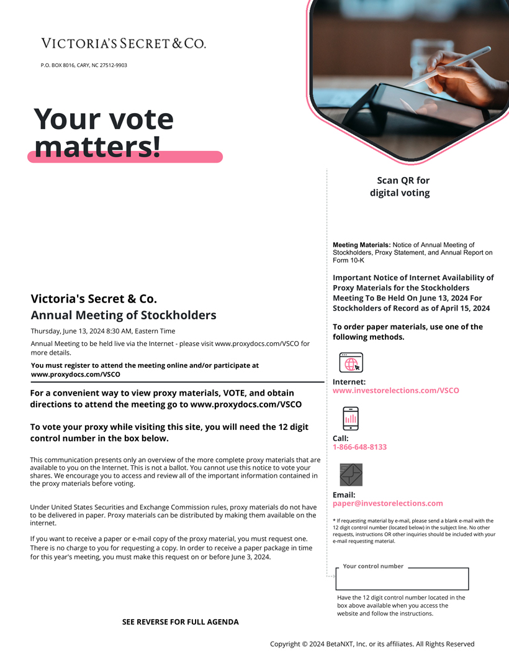
VICTORIAS SECRET & CO.
P.O. BOX 8016, CARY, NC 27512-9903
Your vote matters!
Victorias Secret & Co.
Annual Meeting of Stockholders
Thursday, June 13, 2024 8:30 AM, Eastern Time
Annual Meeting to be held live via the Internet - please visit www.proxydocs.com/VSCO for more details.
You must register to attend the meeting online and/or participate at www.proxydocs.com/VSCO
For a convenient way to view proxy materials, VOTE, and obtain directions to attend the meeting go to www.proxydocs.com/VSCO
To vote your proxy while visiting this site, you will need the 12 digit control number in the box below.
This communication presents only an overview of the more complete proxy materials that are available to you on the Internet. This is not a ballot. You cannot use this notice to vote your shares. We encourage you to access and review all of the important information contained in the proxy materials before voting.
Under United States Securities and Exchange Commission rules, proxy materials do not have to be delivered in paper. Proxy materials can be distributed by making them available on the internet.
If you want to receive a paper or e-mail copy of the proxy material, you must request one. There is no charge to you for requesting a copy. In order to receive a paper package in time for this years meeting, you must make this request on or before June 3, 2024.
SEE REVERSE FOR FULL AGENDA
Scan QR for digital voting
Meeting Materials: Notice of Annual Meeting of Stockholders, Proxy Statement, and Annual Report on Form 10-K
Important Notice of Internet Availability of Proxy Materials for the Stockholders Meeting To Be Held On June 13, 2024 For Stockholders of Record as of April 15, 2024
To order paper materials, use one of the following methods.
Internet:
www.investorelections.com/VSCO
Call:
1-866-648-8133
Email:
paper@investorelections.com
* If requesting material by e-mail, please send a blank e-mail with the 12 digit control number (located below) in the subject line. No other requests, instructions OR other inquiries should be included with your e-mail requesting material.
Your control number
Have the 12 digit control number located in the box above available when you access the website and follow the instructions.
Copyright © 2024 BetaNXT, Inc. or its affiliates. All Rights Reserved

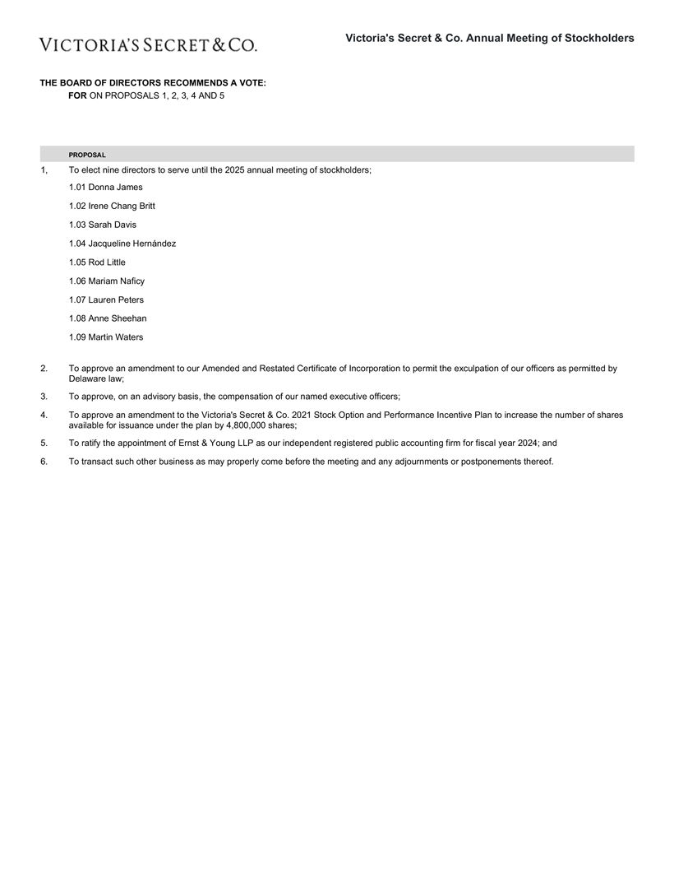
Victorias Secret & Co. Annual Meeting of Stockholders
VICTORIAS SECRET & CO.
THE BOARD OF DIRECTORS RECOMMENDS A VOTE:
FOR ON PROPOSALS 1, 2, 3, 4 AND 5
PROPOSAL
1, To elect nine directors to serve until the 2025 annual meeting of stockholders;
1.01 Donna James
1.02 Irene Chang Britt
1.03 Sarah Davis
1.04 Jacqueline Hernández
1.05 Rod Little
1.06 Mariam Naficy
1.07 Lauren Peters
1.08 Anne Sheehan
1.09 Martin Waters
2. To approve an amendment to our Amended and Restated Certificate of Incorporation to permit the exculpation of our officers as permitted by Delaware law;
3. To approve, on an advisory basis, the compensation of our named executive officers;
4. To approve an amendment to the Victorias Secret & Co. 2021 Stock Option and Performance Incentive Plan to increase the number of shares available for issuance under the plan by 4,800,000 shares;
5. To ratify the appointment of Ernst & Young LLP as our independent registered public accounting firm for fiscal year 2024; and
6. To transact such other business as may properly come before the meeting and any adjournments or postponements thereof.

