UNITED STATES

SECURITIES AND EXCHANGE COMMISSION
Washington, D.C. 20549

SCHEDULE 14A

Proxy Statement Pursuant to Section 14(a) of the
Securities Exchange Act of 1934

(Amendment No. )

Filed by the Registrant ☒

Filed by a party other than the Registrant ☐

Check the appropriate box:

- Preliminary Proxy Statement

- Confidential, for Use of the Commission Only (as Permitted by Rule 14a-6(e)(2))

- Definitive Proxy Statement

- Definitive Additional Materials

- Soliciting Material under § 240.14a-12

Victoria’s Secret & Co.

(Name of Registrant as Specified in its Charter)

(Name of Person(s) Filing Proxy Statement, if other than the Registrant)

Payment of Filing Fee (Check all boxes that apply):

- No fee required

- Fee paid previously with preliminary materials

- Fee computed on table in exhibit required by Item 25(b) per Exchange Act Rules 14a-6(i)(1) and 0-11

On May 18, 2026, Victoria’s Secret & Co. (the “Company”) issued the following press release and letter to stockholders of the Company, the latter of which was mailed to stockholders in the format attached hereto as a courtesy PDF:

Victoria’s Secret & Co. Issues Letter to Shareholders Highlighting Strong Performance, Significant Shareholder Value Creation and Continued Momentum Under Current Leadership

Urges Shareholders to Vote “FOR” All Highly Qualified Directors at the 2026 Annual Meeting of Shareholders

REYNOLDSBURG, Ohio, May 18, 2026 - Victoria’s Secret & Co. (“VS&Co” or the “Company”) (NYSE: VSCO) today issued a letter to shareholders highlighting the significant progress and shareholder value creation achieved under the leadership of Chief Executive Officer Hillary Super and the support of the Company’s Board of Directors (the “Board”).

The letter underscores the Company’s strong operational and financial momentum under its Path to Potential strategy and highlights the Board’s conviction that continued execution of this strategy is the best path to sustained long-term shareholder value creation. Since the announcement of

Ms. Super’s appointment in August 2024, VS&Co has delivered a total shareholder return (“TSR”) of 141%, significantly outperforming the peer group used by research analysts, the S&P 500 Consumer Discretionary Distribution Retail index and the S&P 600.¹ In fiscal year 2025, the Company delivered comparable sales growth, improved profitability, growth across brands, channels and geographies and continued progress across each of the four pillars of the Company’s Path to Potential strategy.

The Company launched VSPathtoPotential.com to provide shareholders with additional information and resources about VS&Co’s strategy to maximize value for shareholders, as well as instructions for how to vote at the 2026 Annual Meeting of Shareholders on Thursday, June 11 (the “Annual Meeting”).

The Board encourages shareholders to vote “FOR” all of the Company’s highly qualified directors at the Annual Meeting to support continued value creation.

The full text of the letter follows:

Dear Fellow Shareholder,

Under CEO Hillary Super’s leadership and with the support of the Board’s active oversight and strategic guidance, Victoria’s Secret & Co. (“VS&Co” or the “Company”) is executing a clear strategy that is creating significant shareholder value.

Since the Board announced Ms. Super’s appointment in August 2024, VS&Co has delivered total shareholder return (“TSR”) of 141%, significantly outperforming the peer group used by research analysts, the S&P 500 Consumer Discretionary Distribution Retail index, and the S&P 600. These results reflect best-in-class financial and operational performance, as well as continued momentum across the business, with growth accelerating in the back half of 2025.

Despite this progress, BBRC International Pte Limited (“BBRC”) and its Chairman Brett Blundy have launched a proxy contest that threatens to disrupt the Company’s momentum, without offering a compelling case for change.

You face an important decision at the Company’s 2026 Annual Meeting of Shareholders (“Annual Meeting”) on Thursday, June 11. We have the right Board with diverse expertise, led by Chair Donna James, and the right leadership team to continue delivering value to shareholders. Why disrupt what is working? A vote “FOR” all of our highly-qualified directors is a vote to maintain our momentum and support continued execution of the Company’s strategy for long-term shareholder value creation.

- Source: FactSet as of May 15, 2026, measured against price at close on unaffected date of August 13, 2024, the date before the public announcement of Ms. Super’s appointment. Analyst peer group includes peers referenced by at least one analyst in initiating coverage research reports and is comprised of Abercrombie & Fitch, American Eagle, Gap, Urban Outfitters, Levi, Buckle, Carter’s, Torrid, Lululemon, Aritzia, Bath & Body Works, Capri, Dillard’s, Genesco, J.Jill, Kohl’s, Macy’s, The Children’s Place, Tilly’s, Tapestry, Zumiez, H&M, Industria de Diseno Textil (Inditex) and Vera Bradley. The S&P 500 Consumer Discretionary Distribution & Retail Index is a point of comparison referenced by BBRC in its public letter dated May 4, 2026.

VS&Co’s Transformation Is Creating Value for Shareholders.
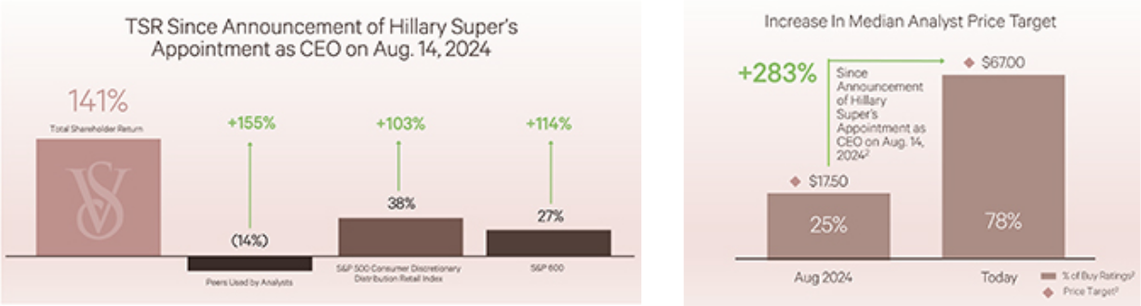

Research Analysts Recognize That Our Strategy Is Working:
“We believe Victoria’s Secret is transitioning from recovery to |  | “…[M]anagement is successfully repositioning its Victoria’s
structural growth, led by innovation in its bra and PINK, |  | Secret and PINK brands... its turnaround playbook is working.
reestablishing relevance.” — Jefferies, 4/23/26³ |  | This should lead to sustained comp sales growth.” — UBS,
 |  | 3/12/26³

“…CEO Hillary Super has now been at the helm for over a year and a half, enough time to identify issues and begin to implement improvements with a newly hired team - and we are bullish on the trajectory of the business under this new team today” — Wells Fargo, 5/8/26³
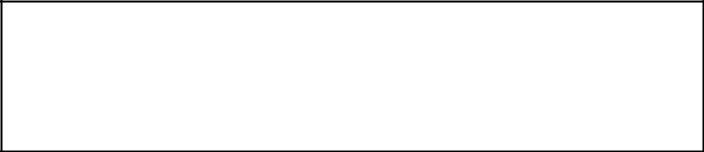

2025 Was A Standout Year For Victoria’s Secret

“The [fourth] quarter was clear evidence that the “Path to Potential” playbook is working and, importantly, is just getting started and becoming repeatable.” — Barclays, 4/5/26³
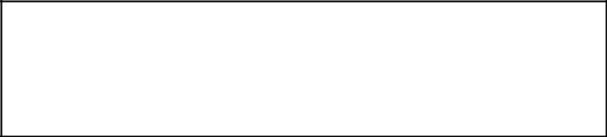

Strong execution against the Path to Potential’s four pillars is driving broad-based progress across the business:

- Supercharge Our Bra Authority: Reasserted leadership in bras

- Recommit to PINK: Reignited PINK, delivered strongest growth year in a decade

- Fueling Growth in Beauty: Grew $1B business with Bombshell, America’s #1 fragrance

- Evolving Our Brand Projection and Go-To-Market Strategy: Grew our customer file for the first time in years and are gaining market share

Strong Financial and Operating Results in Fiscal 2025
Delivered results exceeding top- and bottom-line guidance |  |  | Accelerated comparable sales growth to 5%
Proven strength across brands, channels and geographies |  |  | Adjusted net income grew 15%⁴
- Median of latest analyst research price targets as of May 15, 2026, measured against median of latest analyst research price targets as of

August 13, 2024, the date before the public announcement of Ms. Super’s appointment. % of Buy Ratings includes analyst research reports that issue price targets.
- Permission to re-print analyst notes neither sought nor obtained.

- Represents a non-GAAP financial measure. A reconciliation of Adjusted Net Income Attributable to VS&Co (referred to herein as “Adjusted net income”) to the most directly comparable GAAP financial measure may be found in our historical earnings releases, copies which are available on our investor relations website at victoriassecretandco.com/investors.

Your highly skilled Board, led by independent Chair Donna James, has driven this growth:

- Refreshed the Board with three new independent directors since 2022

- Diverse and balanced skillset across women’s intimates, apparel and beauty, strategic planning, brand transformation, marketing, technology and financial experience

- Appointed Hillary Super CEO after identifying the need for a CEO with merchant leadership expertise who deeply understands how to connect with the customer

- Partnered with Ms. Super to architect and execute the Path to Potential strategy that is driving clear momentum

In the less than two years since Hillary Super’s appointment, VS&Co has built meaningful momentum. We have reestablished our iconic brands, and our most recent results demonstrated accelerated comparable sales growth, improved profitability, stronger customer engagement and clear outperformance against peer and retail benchmarks. Most importantly, we are creating significant value for shareholders.

We encourage shareholders to let management and the Board continue to focus on driving this momentum. Your Board is overseeing a new phase of growth for VS&Co – vote “FOR” your Board to drive continued value creation.

Sincerely,

The Victoria’s Secret & Co. Board of Directors

For more information regarding VS&Co’s momentum and highly-qualified Board, please visit: VSPathtoPotential.com

YOUR VOTE IS IMPORTANT.

To ensure your shares are represented at the Annual Meeting, please submit your vote TODAY: Use the WHITE Proxy Card to Vote “FOR” All of VS&Co’s Highly Qualified Nominees

If you have any questions or require any assistance with voting your shares, please call the Company’s proxy solicitor:

INNISFREE M&A INCORPORATED
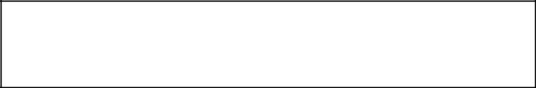

Shareholders, please call: (877) 750-0831

(toll free from the U.S. and Canada) or

+1 (412) 232-3651 (from all other countries)

About Victoria’s Secret & Co

Victoria’s Secret & Co. (NYSE: VSCO) is a specialty retailer of modern, fashion-inspired collections including signature bras, panties, lingerie, sleepwear, apparel, sport and swim as well as award-winning prestige fragrances and body care. VS&Co is comprised of market leading brands, Victoria’s Secret and PINK, that strive to inspire confidence, spark joy and celebrate sexy. Additionally, Adore Me, our digital intimates brand serves women across budgets and lifestyles. We are committed to empowering our more than 30,000 associates across a global footprint of 1,420 retail stores in approximately 70 countries.

Safe Harbor Statement Under the Private Securities Litigation Reform Act of 1995

This document contains forward-looking statements within the meaning of the U.S. Private Securities Litigation Reform Act of 1995. These statements, which may be identified by words such as “estimate,” “commit,” “will,” “target,” “forecast,” “goal,” “project,” “plan,” “believe,” “seek,” “strive,” “expect,” “anticipate,” “intend,” “continue,” “potential” or the negative of these words and any similar expressions, involve risks and uncertainties, many of which are beyond our control, and are not guarantees of future performance. Actual results may differ materially from those expressed or implied in any forward-looking statement.

Factors that could cause actual results to differ include, among others: general economic conditions, inflation, and changes in consumer confidence and consumer spending patterns; market disruptions; uncertainty in the global trade environment, including tariffs and retaliatory measures; our ability to successfully implement our strategic plan; leadership changes and turnover in key positions; our ability to source, produce, distribute and sell merchandise globally, including risks related to geopolitical conflicts, supply chain disruptions (and related pricing impacts), currency fluctuations and labor disputes; fluctuations in freight, product input and energy costs; cybersecurity risks and our ability to maintain data security and privacy; shareholder activism matters; and other risks and uncertainties described in “Item 1A. Risk Factors” in our 2025 Annual Report on Form 10-K filed with the SEC on March 20, 2026.

All forward-looking statements are made only as of the date of this document. Except as may be required by law, we assume no obligation to make publicly available any update or other revisions to any of the forward-looking statements contained in this document.

For further information, please contact:

Victoria’s Secret & Co.:

Investor Relations:

investorrelations@victoria.com

Media Relations:

Edelman Smithfield

VSCO@edelmansmithfield.com

