UNITED STATES
SECURITIES AND EXCHANGE COMMISSION
Washington, D.C. 20549

SCHEDULE 14A INFORMATION
Proxy Statement Pursuant to Section 14(a) of the
Securities Exchange Act of 1934

Filed by the Registrant ☒ Filed by a party other than the Registrant ☐
Check the appropriate box:

☐ | Preliminary Proxy Statement

☐ | Confidential, for Use of the Commission Only (as permitted by Rule 14a-6(e)(2))

☐ | Definitive Proxy Statement

☒ | Definitive Additional Materials

☐ | Soliciting Material under § 240.14a-12
VICTORIAS SECRET & CO.
(Name of Registrant as Specified in Its Charter)
N/A
(Name of Person(s) Filing Proxy Statement, if other than the Registrant)
Payment of Filing Fee (Check the appropriate box):

☒ | No fee required.

☐ | Fee paid previously with preliminary materials.

☐ | Fee computed on table in exhibit required by Item 25(b) per Exchange Act Rules 14a-6(i)(1) and 0-11.

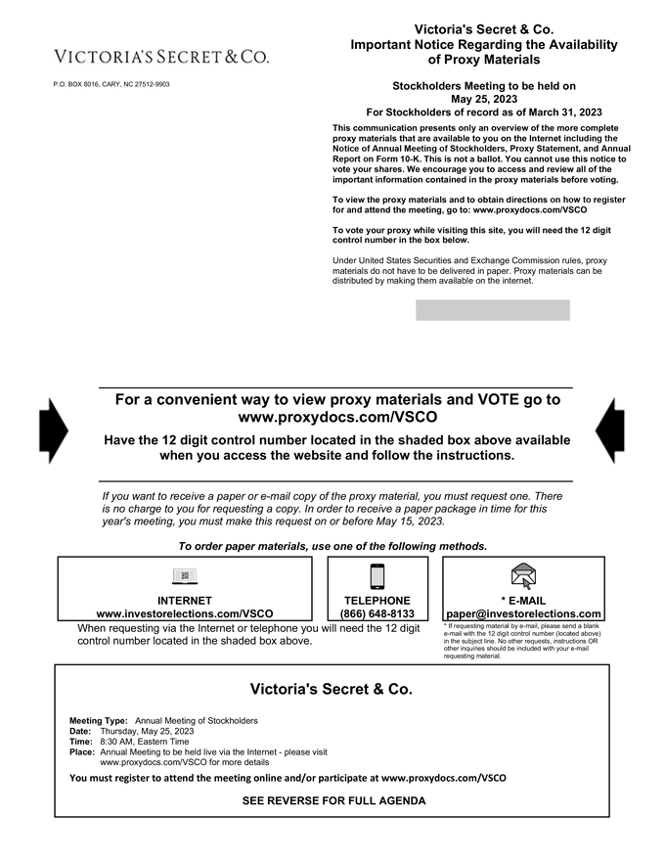
P.O. BOX 8016, CARY, NC 27512-9903
Victorias Secret & Co.
Important Notice Regarding the Availability of Proxy Materials
Stockholders Meeting to be held on May 25, 2023
For Stockholders of record as of March 31, 2023
This communication presents only an overview of the more complete proxy materials that are available to you on the Internet including the Notice of Annual Meeting of Stockholders, Proxy Statement, and Annual Report on Form 10-K. This is not a ballot. You cannot use this notice to vote your shares. We encourage you to access and review all of the important information contained in the proxy materials before voting. To view the proxy materials and to obtain directions on how to register for and attend the meeting, go to: www.proxydocs.com/VSCO
To vote your proxy while visiting this site, you will need the 12 digit control number in the box below.
Under United States Securities and Exchange Commission rules, proxy materials do not have to be delivered in paper. Proxy materials can be distributed by making them available on the internet.
For a convenient way to view proxy materials and VOTE go to www.proxydocs.com/VSCO
Have the 12 digit control number located in the shaded box above available when you access the website and follow the instructions.
If you want to receive a paper or e-mail copy of the proxy material, you must request one. There is no charge to you for requesting a copy. In order to receive a paper package in time for this years meeting, you must make this request on or before May 15, 2023.
To order paper materials, use one of the following methods.
INTERNET www.investorelections.com/VSCO
TELEPHONE (866) 648-8133
* E-MAIL paper@investorelections.com
When requesting via the Internet or telephone you will need the 12 digit control number located in the shaded box above.
* If requesting material by e-mail, please send a blank e-mail with the 12 digit control number (located above) in the subject line. No other requests, instructions OR other inquiries should be included with your e-mail requesting material.
Victorias Secret & Co.
Meeting Type: Annual Meeting of Stockholders Date: Thursday, May 25, 2023 Time: 8:30 AM, Eastern Time
Place: Annual Meeting to be held live via the Internetplease visit www.proxydocs.com/VSCO for more details
You must register to attend the meeting online and/or participate at www.proxydocs.com/VSCO
SEE REVERSE FOR FULL AGENDA

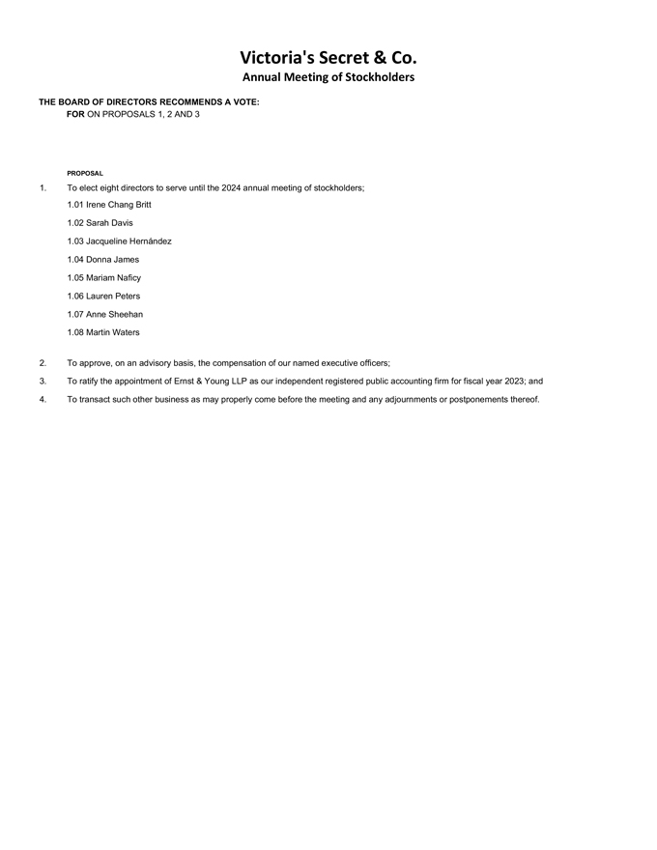
Victorias Secret & Co.
Annual Meeting of Stockholders
THE BOARD OF DIRECTORS RECOMMENDS A VOTE: FOR ON PROPOSALS 1, 2 AND 3
PROPOSAL
1. To elect eight directors to serve until the 2024 annual meeting of stockholders;
1.01 Irene Chang Britt
1.02 Sarah Davis
1.03 Jacqueline Hernández
1.04 Donna James
1.05 Mariam Naficy
1.06 Lauren Peters
1.07 Anne Sheehan
1.08 Martin Waters
2. To approve, on an advisory basis, the compensation of our named executive officers;
3. To ratify the appointment of Ernst & Young LLP as our independent registered public accounting firm for fiscal year 2023; and
4. To transact such other business as may properly come before the meeting and any adjournments or postponements thereof.

